**Idris Ratlamwala**

**C31 – 2003145**

**CG - Journal , Assingments & MPR project**

|  |  |
| --- | --- |
| **SR.No.** | **TOPICS** |
| 1. | Implement DDA Line drawing Method in C |
| 2. | Implement Bresenham’s Line drawing Method in C |
| 3. | Implement Midpoint circle drawing Method in C |
| 4. | Implement Midpoint ellipse drawing Method in C |
| 5. | Implement flood fill and boundary fill to fill a polygon. |
| 6. | Implement 2D Transformations on a polygon – Translation, Rotation, Scaling,  Reflection and Shear |
| 7. | Implement Bezier curve |
| 8. | Implement Koch Curve for fractal generation |
| 9. | Implement Liang Barsky Line clipping Method in C |
| 10. | Implement Sutherland Hodgeman polygon clipping Method in C |
| 11. | Assingment 1 |
| 12. | Assingment 2 |
| 13. | Mini Project : [ Pacman Game ] |

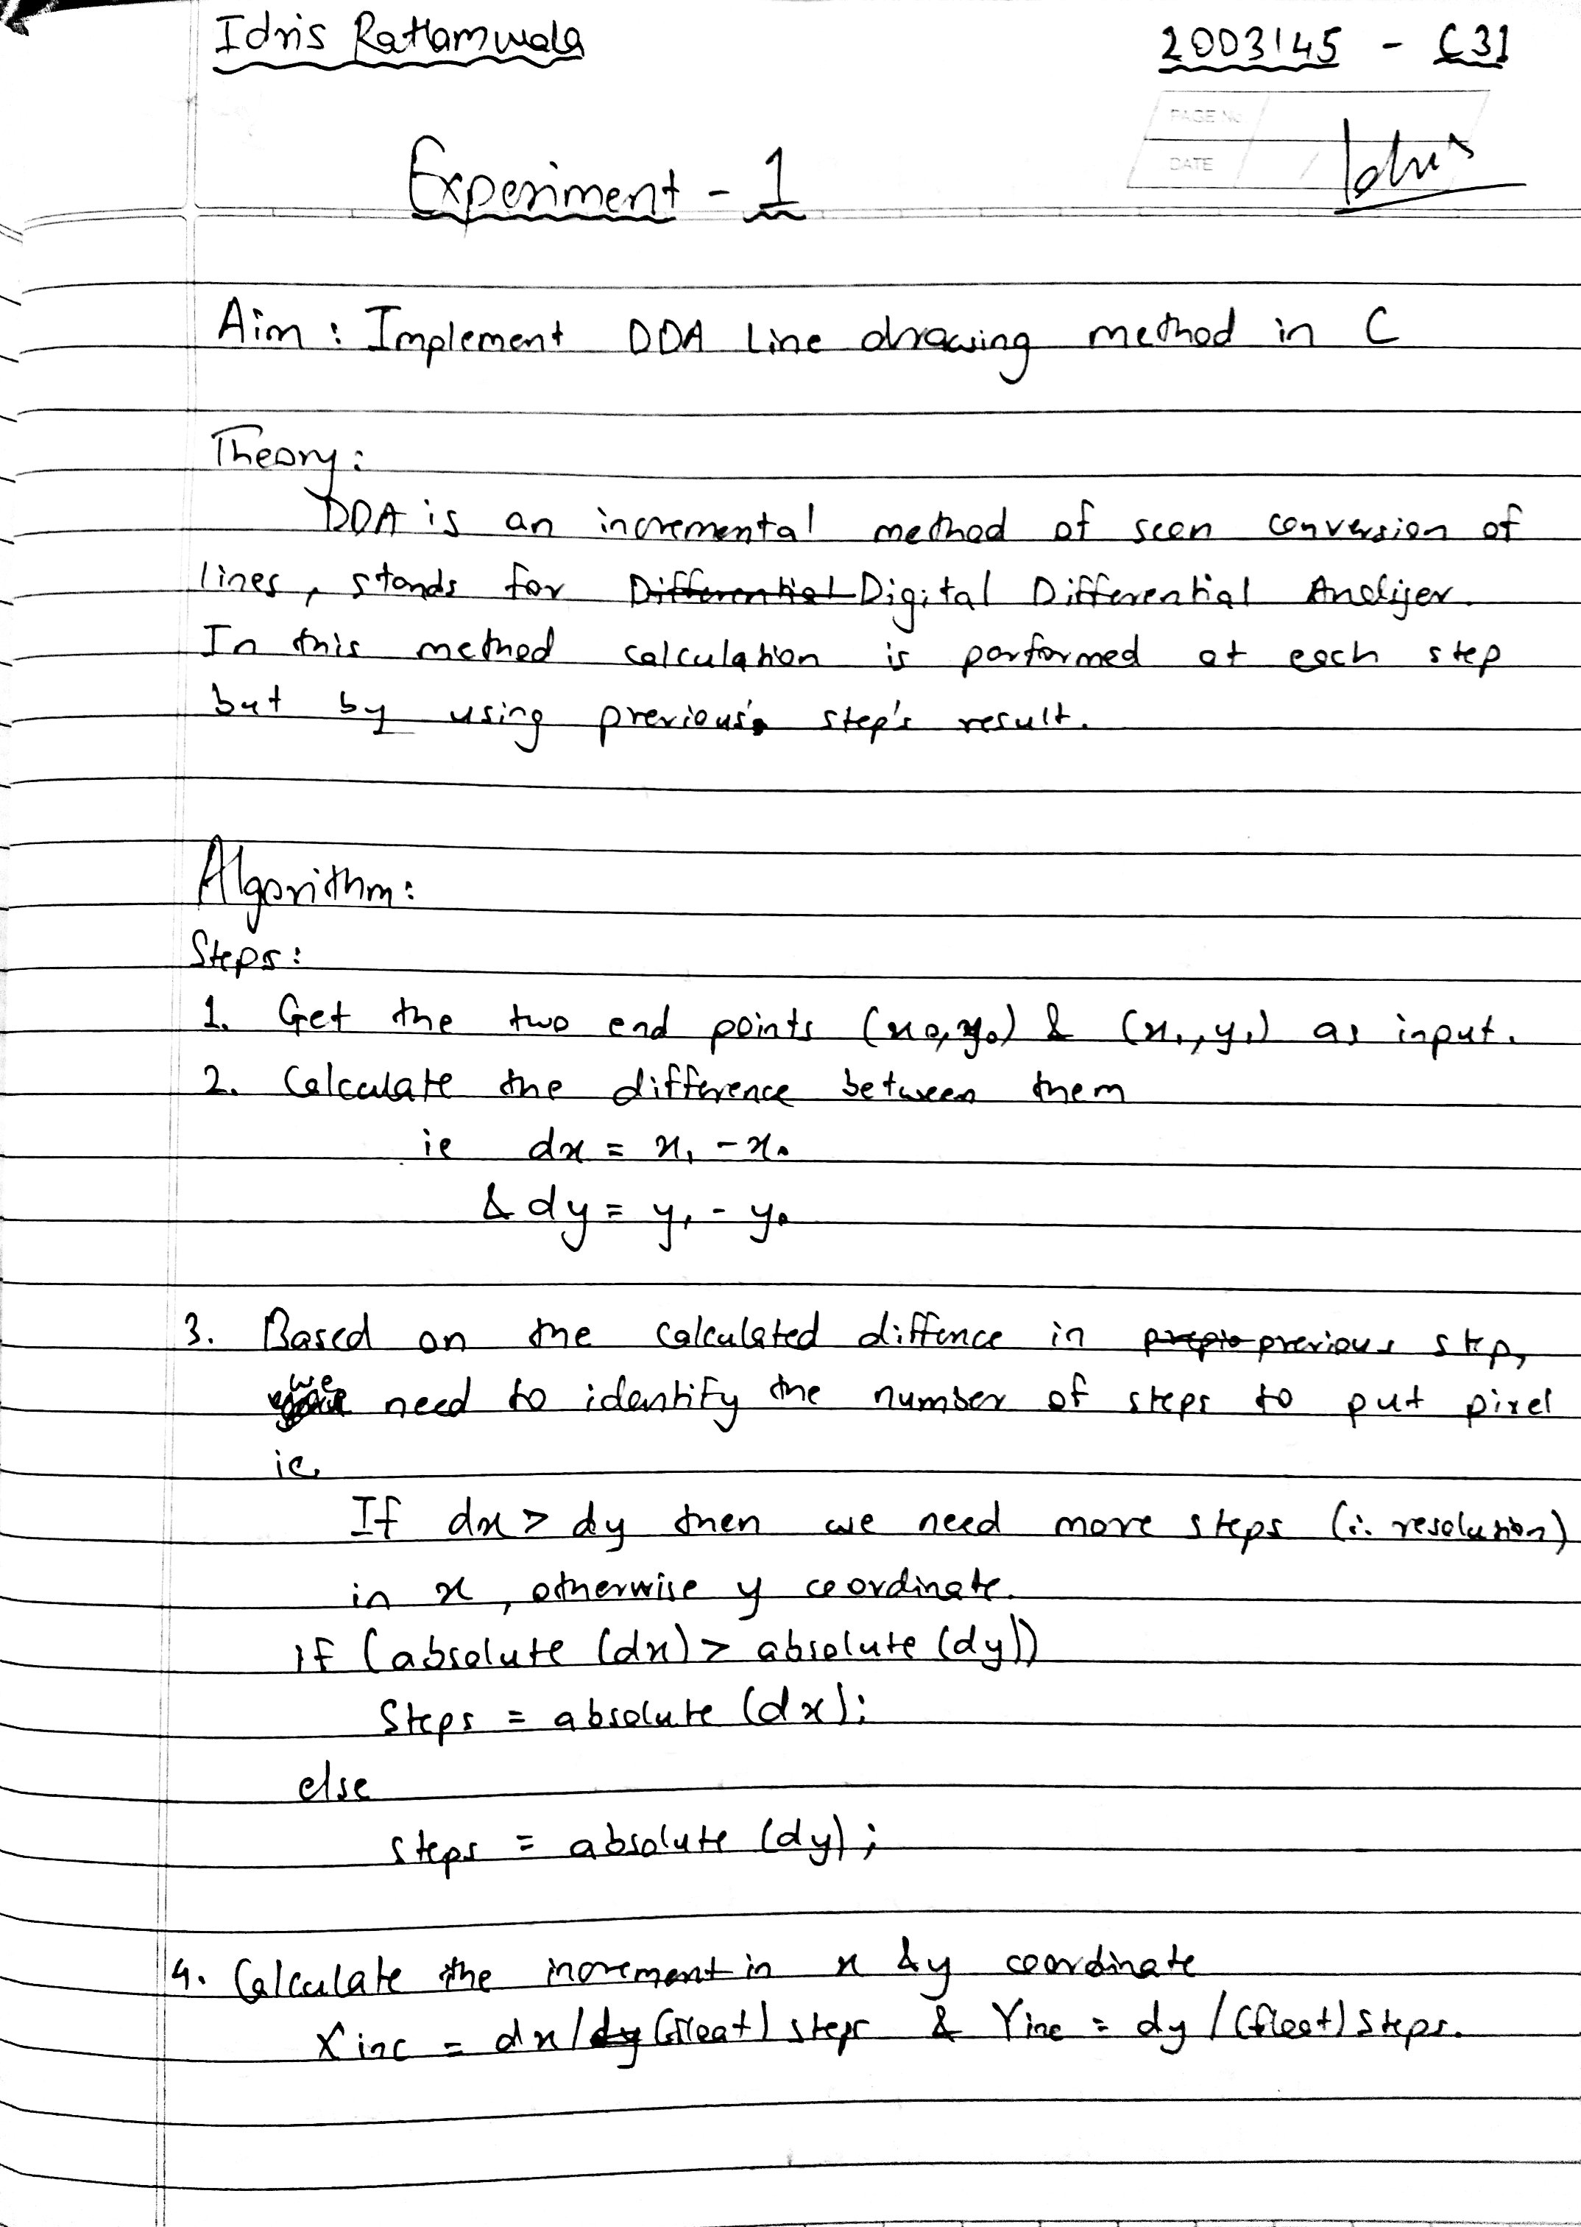**Basic DDA :**

#include <stdio.h>

#include <conio.h>

#include <graphics.h>

#include <math.h>

int sign(float);

void main()

{

  int gd = DETECT, gm, i = 0, k,steps;

  float x1, x2, y1, y2, dx, dy, xinc, yinc, x, y;

  clrscr();

  initgraph(&gd, &gm, "C:\\TURBOC3\\BGI");

  printf("Enter start cooordinates:\n");

  scanf("%f %f", &x1, &y1);

  printf("Enter end coordinates:\n");

  scanf("%f %f", &x2, &y2);

  if (x1 == x2 && y1 == y2) // m=45

    putpixel((int)x1, (int)y1, 15);

  else

  {

    dx = x2 - x1;

    dy = y2 - y1;

    if (abs(dx) >= abs(dy)) //m<45

      steps = abs(dx);

    else                    //m>45

      steps = abs(dy);

    xinc = dx / steps;

    yinc = dy / steps;

    x = x1 + 0.5 * sign(xinc);

    y = y1 + 0.5 * sign(yinc);

    while (i < steps)

    {

      putpixel((int)x, (int)y, 15);

      x = x + xinc;

      y = y + yinc;

      i++;

    }

  }

  getch();

  // line(x1,y1,x2,y2);

  closegraph();

}

int sign(float n)

{

  if (n < 0) return -1;

  else if (n > 0) return 1;

  return 0;

}

**Output :**

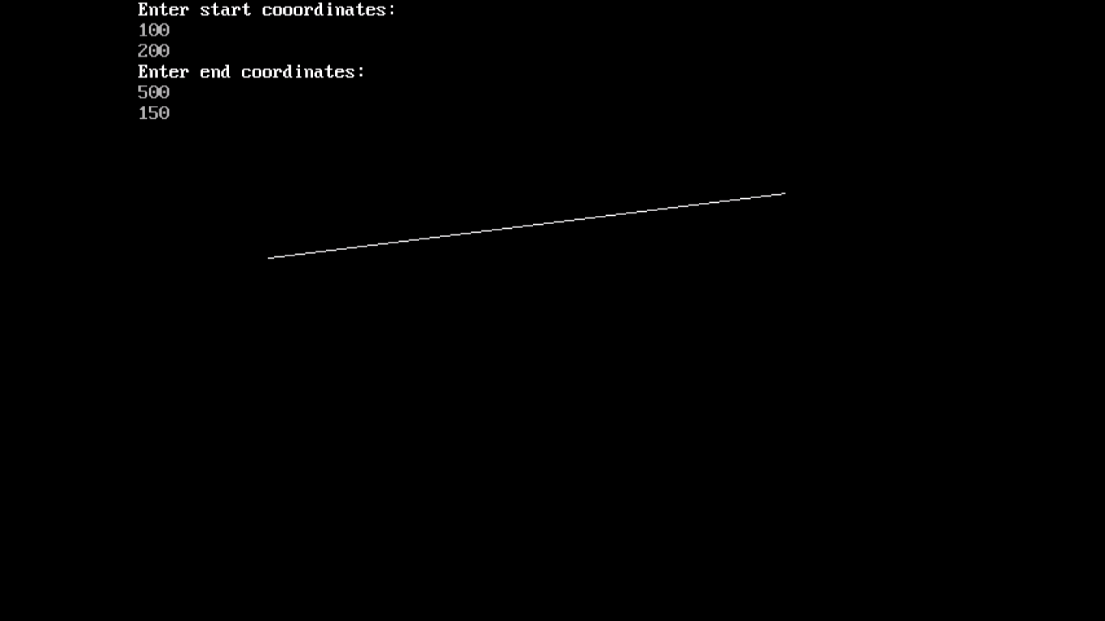

**Dotted DDA :**

#include <stdio.h>

#include <graphics.h>

#include <math.h>

int roundNo(float num)

{

    return num < 0 ? num - 0.5 : num + 0.5;

}

void main()

{

    int gd = DETECT, gm = DETECT,dx,dy,steps,k;

    float x1, y1, x2, y2, x, y,xinc,yinc;

    printf("\n Enter two end points of a line:");

    printf("Enter x1,y1: ");

    scanf("%f %f", &x1, &y1);

    printf("Enter x2,y2 : ");

    scanf("%f %f", &x2, &y2);

    initgraph(&gd, &gm, "C:\\TURBOC3\\BGI");

    x = x1;

    y = y1;

    putpixel(roundNo(x), roundNo(y), WHITE);

    dx = x2 - x1;

    dy = y2 - y1;

    if (abs(dx) > abs(dy))

        steps = abs(dx);

    else

        steps = abs(dy);

    xinc = (float)dx / steps;

    yinc = (float)dy / steps;

    for (k = 1; k <= steps; k++)

    {

        x = x + xinc;

        y = y + yinc;

        if ((int)roundNo(x) % 10 == 0 || (int)roundNo(y) % 10 == 0)

            putpixel(roundNo(x), roundNo(y), WHITE);

        else

            putpixel(roundNo(x), roundNo(y), BLACK);

    }

    getch();

}



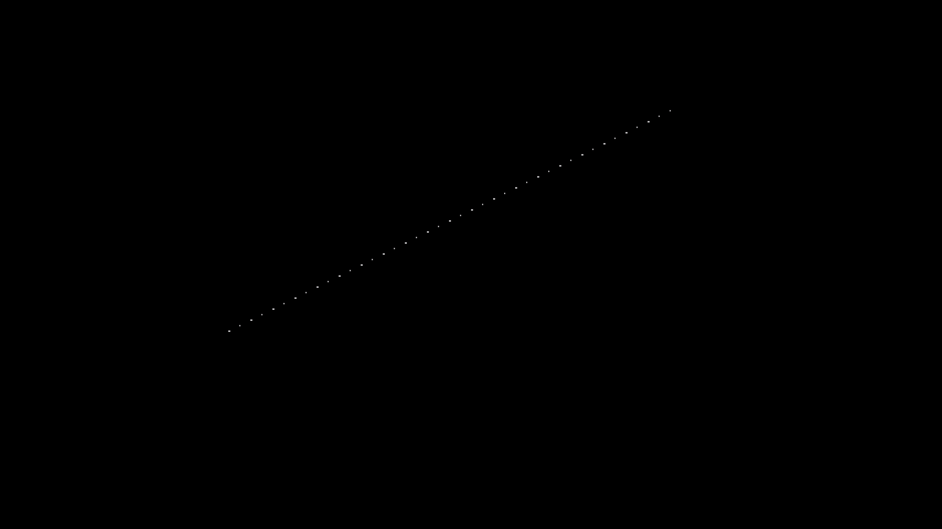

**Dashed DDA :**

#include <stdio.h>

#include <graphics.h>

#include <math.h>

int roundNo(float num)

{

    return num < 0 ? num - 0.5 : num + 0.5;

}

void main()

{

    int gd = DETECT, gm = DETECT,dx,dy,steps,k;

    float x1, y1, x2, y2, x, y,xinc,yinc;

    printf("\n Enter two end points of a line:");

    printf("Enter x1,y1: ");

    scanf("%f %f", &x1, &y1);

    printf("Enter x2,y2 : ");

    scanf("%f %f", &x2, &y2);

    initgraph(&gd, &gm, "C:\\TURBOC3\\BGI");

    x = x1;

    y = y1;

    putpixel(roundNo(x), roundNo(y), WHITE);

    dx = x2 - x1;

    dy = y2 - y1;

    if (abs(dx) > abs(dy))

        steps = abs(dx);

    else

        steps = abs(dy);

    xinc = (float)dx / steps;

    yinc = (float)dy / steps;

    for (k = 1; k <= steps; k++)

    {

        x = x + xinc;

        y = y + yinc;

        if ((int)roundNo(x) % 10 == 0 || (int)roundNo(y) % 10 == 0)

            putpixel(roundNo(x), roundNo(y), BLACK);

        else

            putpixel(roundNo(x), roundNo(y), WHITE);

    }

    getch();

}

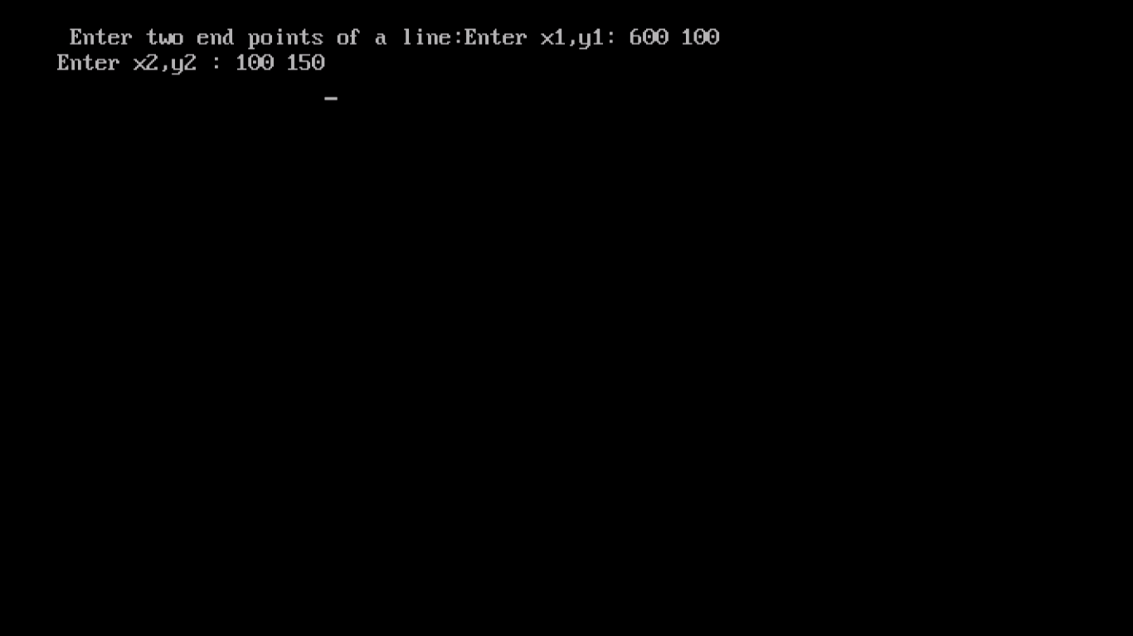

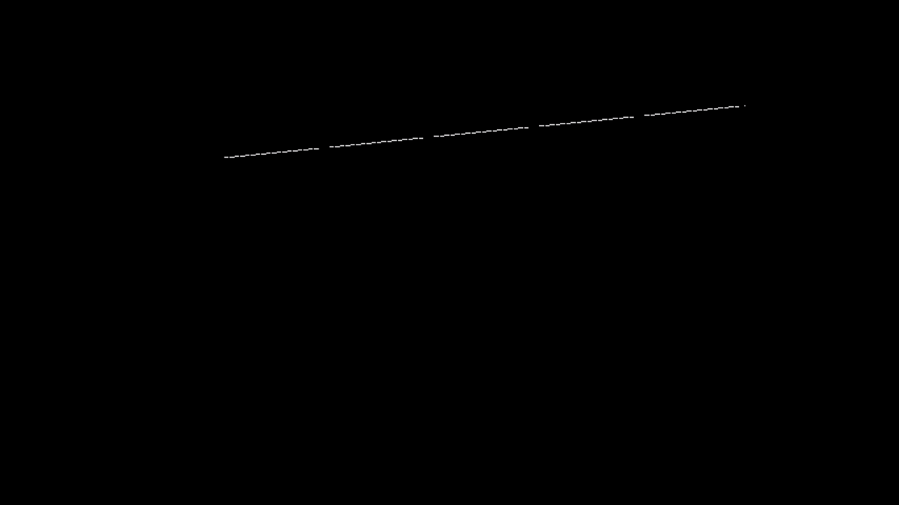

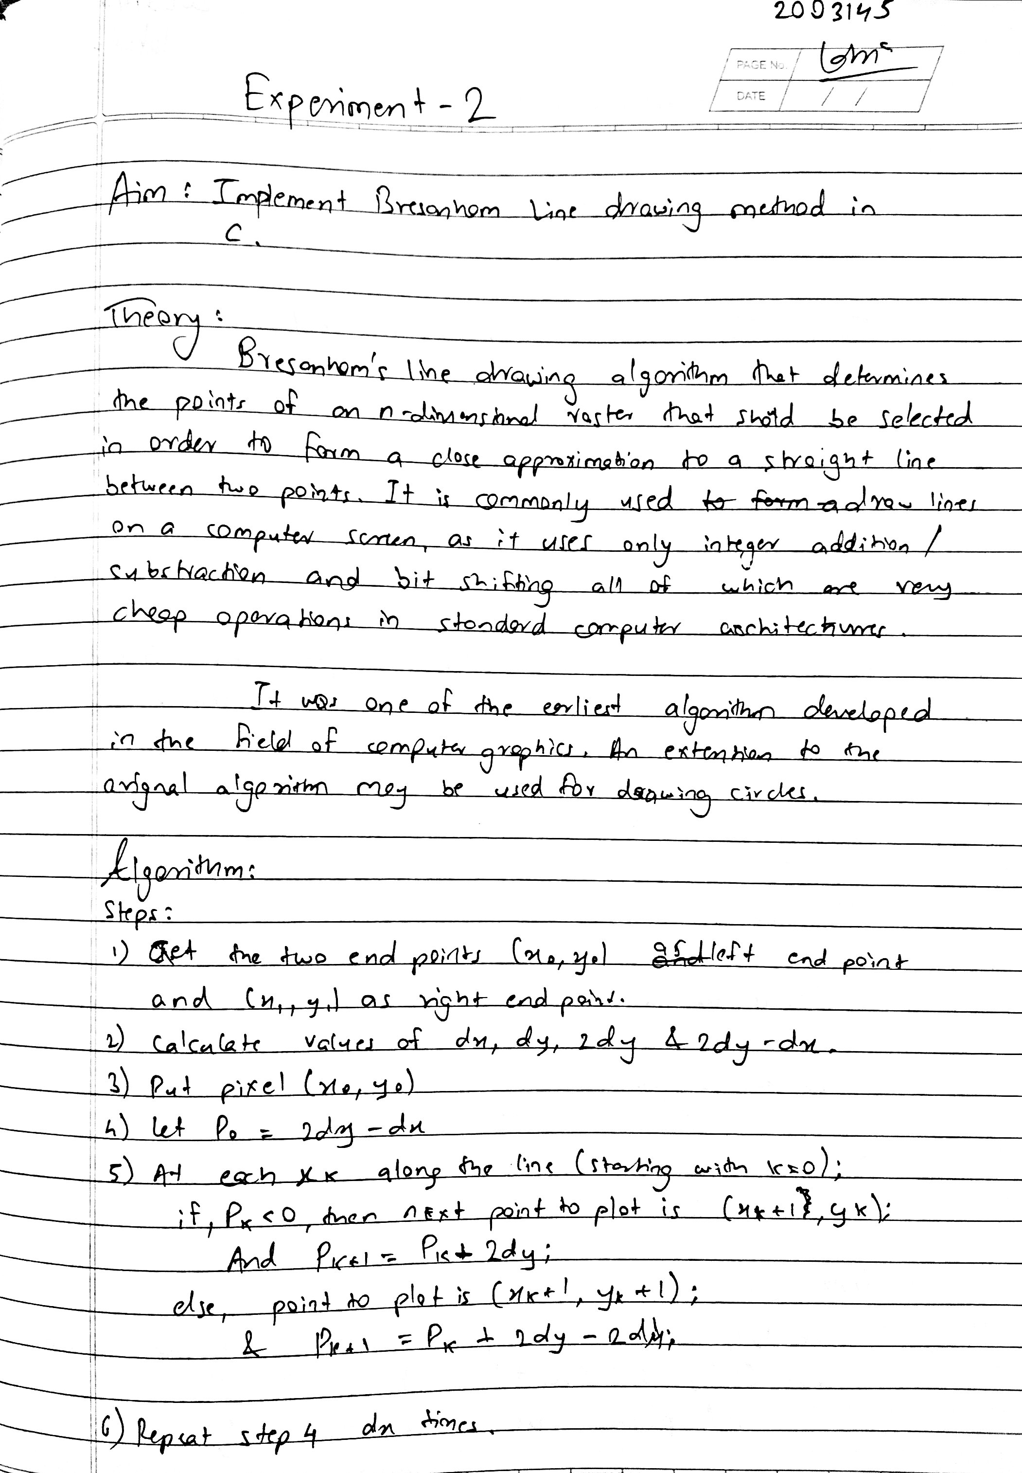

**Bresanham basic :**

#include <stdio.h>

#include <graphics.h>

#include <math.h>

#include <conio.h>>

int roundNo(float num)

{

    return num < 0 ? num - 0.5 : num + 0.5;

}

void main()

{

    int gd = DETECT, gm, i, dx, dy, s1, s2, f = 0, p;

    float x1, y1, x2, y2, x, y, temp;

    clrscr();

    printf("Enter x1,y1: ");

    scanf("%f %f", &x1, &y1);

    printf("Enter x2,y2 : ");

    scanf("%f %f", &x2, &y2);

    initgraph(&gd, &gm, "C:\\TURBOC3\\BGI");

    x = x1;

    y = y1;

    putpixel(roundNo(x), roundNo(y), WHITE);

    dx = abs(x2 - x1);

    dy = abs(y2 - y1);

    if (x2 - x1 < 0)

    s1 = -1;

    if (x2 - x1 > 0)

    s1 = 1;

    if (y2 - y1 < 0)

    s2 = -1;

    if (y2 - y1 > 0)

    s2 = 1;

    if (dy > dx)

    {

    temp = dx;

    dx = dy;

    dy = temp;

    f = 1;

    }

    p = 2 * dy - dx;

    for (i = 1; i <= dx; i++)

    {

    if (p < 0)

    {

        if (f == 1)

        y = y + s2;

        else

        x = x + s1;

        p = p + 2 * dy;

    }

    else

    {

        x = x + s1;

        y = y + s2;

        p = p + 2 * dy - 2 * dx;

    }

    putpixel(roundNo(x), roundNo(y), WHITE);

    }

    getch();

}

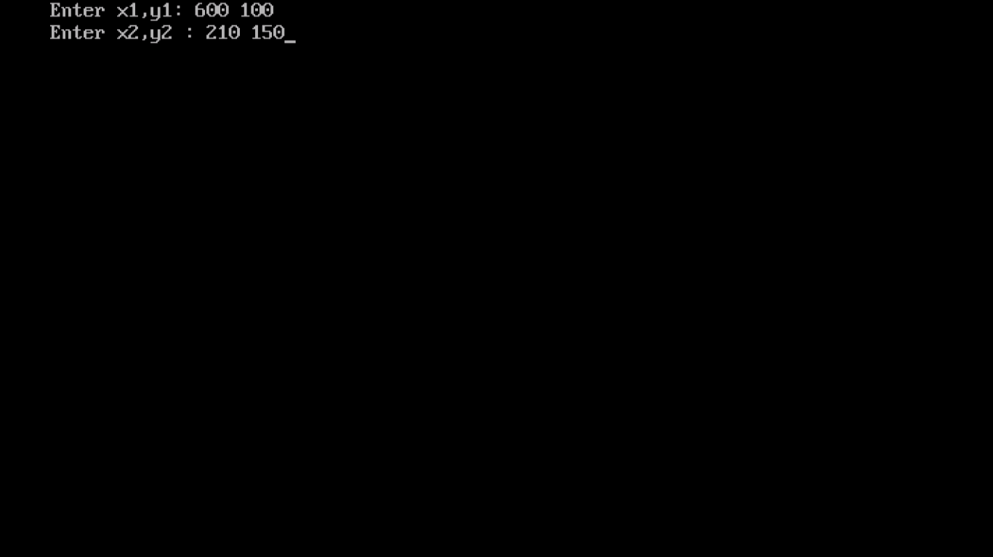

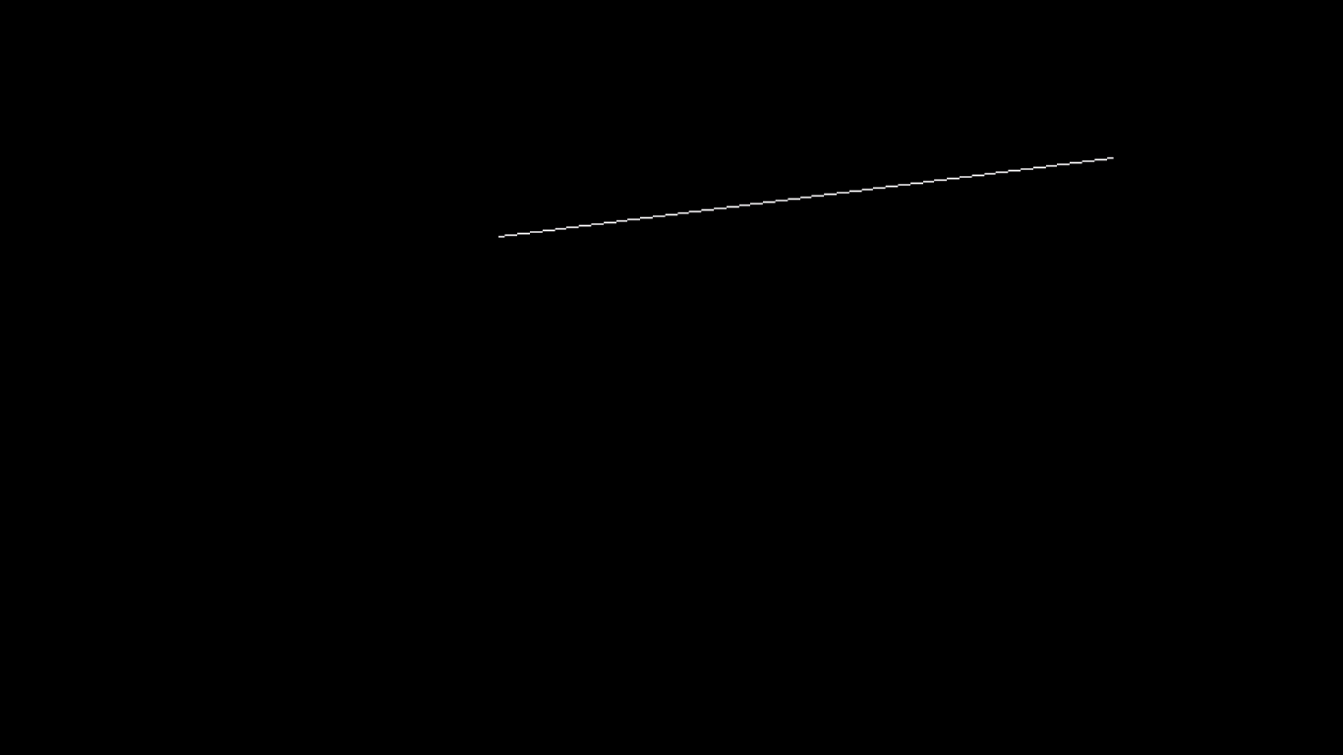

**Bresanham thick :**

#include <stdio.h>

#include <graphics.h>

#include<conio.h>

#include <math.h>

int roundNo(float num)

{

    return num < 0 ? num - 0.5 : num + 0.5;

}

 void main()

{

 int gd = DETECT, gm = DETECT;

 float x1, y1, x2, y2, x, y, temp;

 int s1, s2, f = 0, p, choice,dx,dy,i;

 printf("\n Enter two end points of a line:");

 printf("Enter x1,y1: ");

 scanf("%f %f", &x1, &y1);

 printf("Enter x2,y2 : ");

 scanf("%f %f", &x2, &y2);

 printf("Enter thickness:1,2,3,4,5:");

 scanf("%d", &choice);

initgraph(&gd, &gm, "C:\\TURBOC3\\BGI");

 x = x1;

 y = y1;

 putpixel(roundNo(x), roundNo(y), WHITE);

  dx = abs(x2 - x1);

  dy = abs(y2 - y1);

 if (x2 - x1 < 0)

 s1 = -1;

 if (x2 - x1 > 0)

 s1 = 1;

 if (y2 - y1 < 0)

s2 = -1;

 if (y2 - y1 > 0)

 s2 = 1;

 if (dy > dx)

 {

 temp = dx;

 dx = dy;

 dy = temp;

 f = 1;

 }

 p = 2 *dy - dx;

 for (i = 1; i <= dx; i++)

 {

 if (p < 0)

 {

 if (f == 1)

 y = y + s2;

 else

 x = x + s1;

 p = p + 2 * dy;

 }

 else

 {

 x = x + s1;

 y = y + s2;

 p = p + 2 *dy - 2 * dx;

 }

 switch (choice)

 {

 case 1:

 putpixel(roundNo(x), roundNo(y), WHITE);

 break;

 case 2:

 putpixel(roundNo(x), roundNo(y), WHITE);

 putpixel(roundNo(x + 1), roundNo(y), WHITE);

 break;

 case 3:

putpixel(roundNo(x), roundNo(y), WHITE);

 putpixel(roundNo(x + 1), roundNo(y), WHITE);

 putpixel(roundNo(x - 1), roundNo(y), WHITE);

 break;

 case 4:

 putpixel(roundNo(x), roundNo(y), WHITE);

 putpixel(roundNo(x + 1), roundNo(y), WHITE);

 putpixel(roundNo(x - 1), roundNo(y), WHITE);

 putpixel(roundNo(x + 2), roundNo(y), WHITE);

 break;

 case 5:

 putpixel(roundNo(x), roundNo(y), WHITE);

 putpixel(roundNo(x + 1), roundNo(y), WHITE);

 putpixel(roundNo(x - 1), roundNo(y), WHITE);

 putpixel(roundNo(x + 2), roundNo(y), WHITE);

 putpixel(roundNo(x - 2), roundNo(y), WHITE);

 break;

 default:

 printf("Wrong input");

 }

 }

 getch();

}

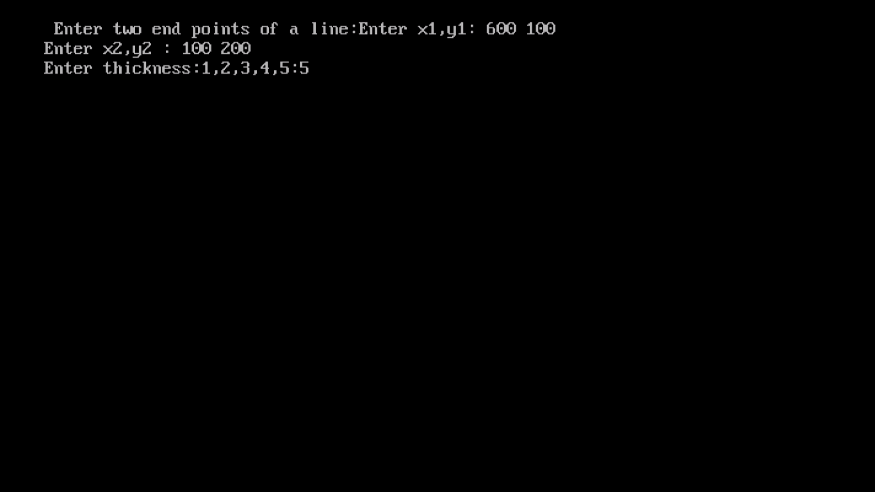

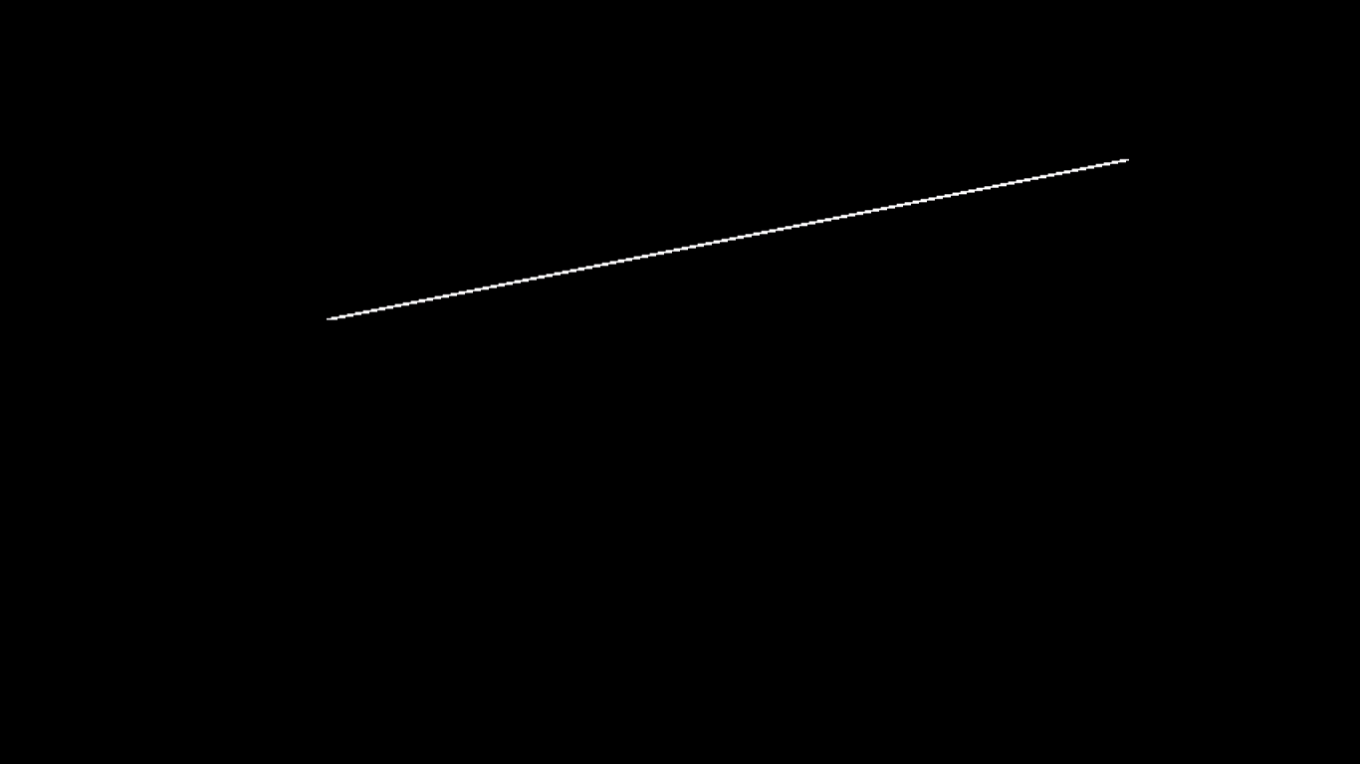

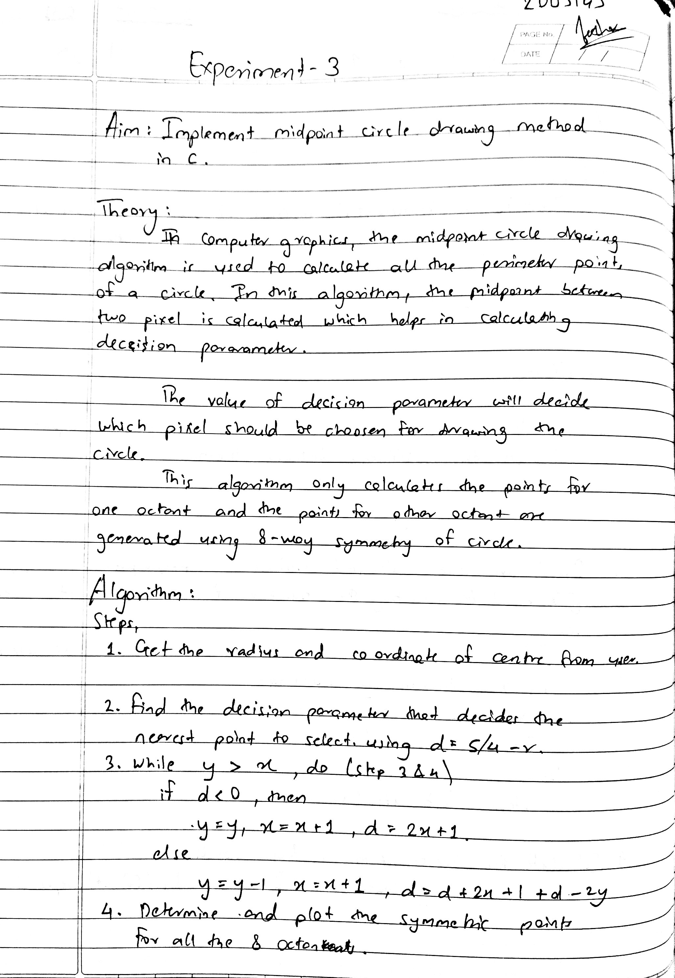

Midpoint method with cocentric circles :

#include <stdio.h>

#include <graphics.h>

void drawCircle(int xc, int yc, int x, int y)

{

    putpixel(xc + x, yc + y, WHITE);

    putpixel(xc - x, yc + y, WHITE);

    putpixel(xc + x, yc - y, WHITE);

    putpixel(xc - x, yc - y, WHITE);

    putpixel(xc + y, yc + x, WHITE);

    putpixel(xc - y, yc + x, WHITE);

    putpixel(xc + y, yc - x, WHITE);

    putpixel(xc - y, yc - x, WHITE);

}

int main()

{

    int gd = DETECT, gm = DETECT, i, x, y, p;

    int xc, yc, rad[20], n;

    printf("Enter co-ordinates of centre(x,y): \n");

    scanf("%d %d", &xc, &yc);

    printf("Enter the number of cricles:\n");

    scanf("%d", &n);

    for (i = 0; i < n; i++)

    {

        printf("\nEnter Radius for circle %d: ", i + 1);

        scanf("%d", &rad[i]);

    }

    initgraph(&gd, &gm, "C:\\TURBOC3\\BGI");

    for (i = 0; i < n; i++)

    {

        x = 0;

        y = rad[i];

        p = 1 - rad[i];

        do

        {

            drawCircle(xc, yc, x, y);

            if (p < 0)

                p = p + 2 * x + 3;

            else

            {

                p = p + 2 * (x - y) + 5;

                y--;

            }

            x++;

        } while (x < y);

    }

    getch();

    return (0);

}

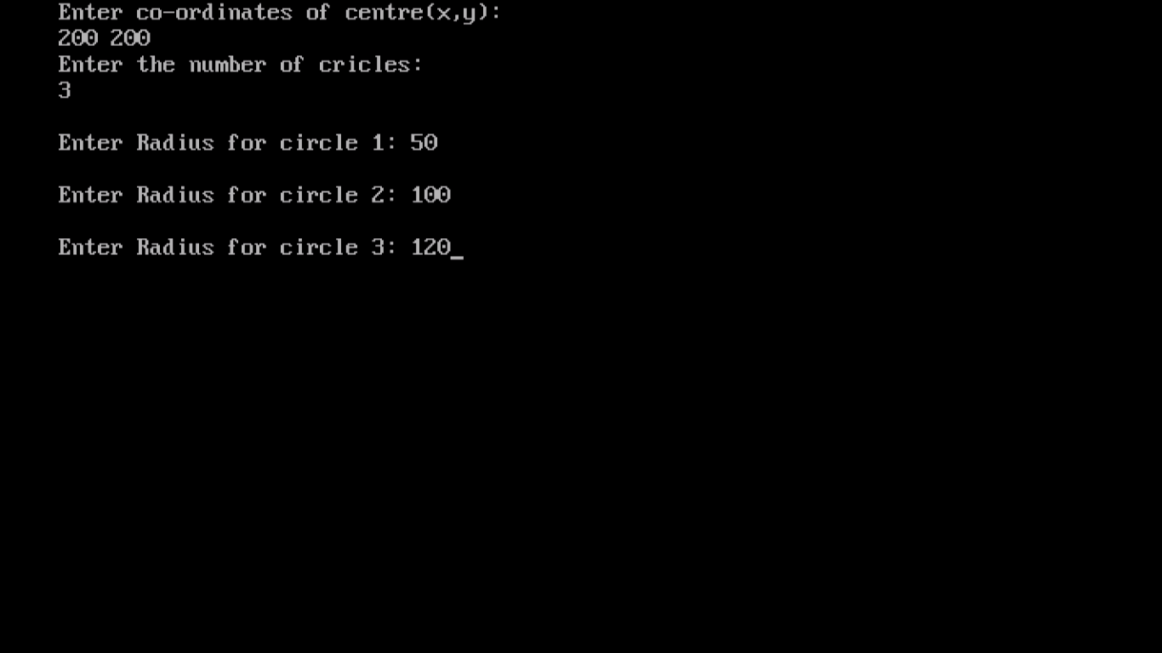

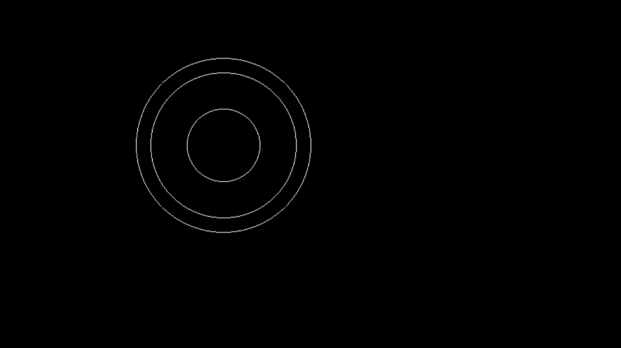

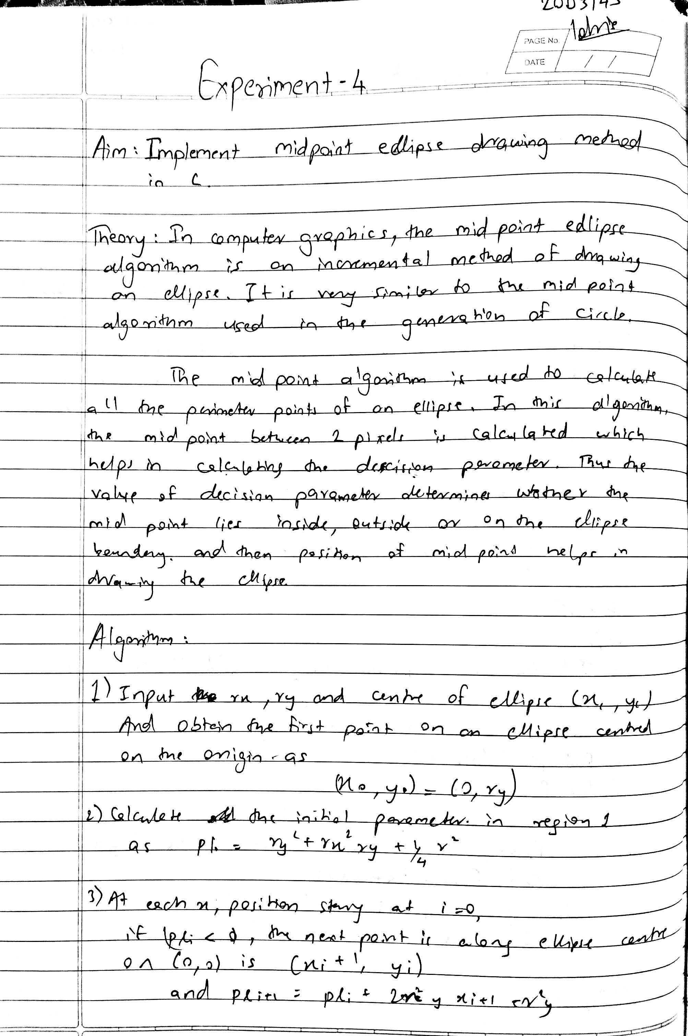

**Program :**

#include <stdio.h>

#include <graphics.h>

#include <math.h>

int main()

{

    int d1, d2;

    int gd = DETECT, gm , x, y;

    int xc, yc, rx, ry, rxsq, rysq, tworxsq, tworysq, dx, dy;

    printf("Enter the value of Xc :");

    scanf("%d", &xc);

    printf("Enter the value of Yc :");

    scanf("%d", &yc);

    printf("Enter the x Radius of the ellipse : ");

    scanf("%d", &rx);

    printf("Enter the y Radius of the ellipse : ");

    scanf("%d", &ry);

    initgraph(&gd, &gm, "C:\\TURBOC3\\BGI");

    rxsq = rx * rx;

    rysq = ry * ry;

    tworxsq = 2 * rxsq;

    tworysq = 2 * rysq;

    x = 0;

    y = ry;

    d1 = rysq - (rxsq * ry) + (0.25 * rxsq);

    dx = tworysq * x;

    dy = tworxsq * y;

    do

    {

        putpixel(xc + x, yc + y, YELLOW);

        putpixel(xc - x, yc - y, YELLOW);

        putpixel(xc + x, yc - y, YELLOW);

        putpixel(xc - x, yc + y, YELLOW);

        if (d1 < 0)

        {

            x = x + 1;

            y = y;

            dx = dx + tworysq;

            d1 = d1 + dx + rysq;

        }

        else

        {

            x = x + 1;

            y = y - 1;

            dx = dx + tworysq;

            dy = dy - tworxsq;

            d1 = d1 + dx - dy + rysq;

        }

    } while (dx < dy);

    d2 = rysq * (x + 0.5) * (x + 0.5) + rxsq * (y - 1) * (y - 1) - rxsq * rysq;

    do

    {

        putpixel(xc + x, yc + y, YELLOW);

        putpixel(xc - x, yc - y, YELLOW);

        putpixel(xc + x, yc - y, YELLOW);

        putpixel(xc - x, yc + y, YELLOW);

        if (d2 > 0)

        {

            x = x;

            y = y - 1;

            dy = dy - tworxsq;

            d2 = d2 - dy + rxsq;

        }

        else

        {

            x = x + 1;

            y = y - 1;

            dy = dy - tworxsq;

            dx = dx + tworysq;

            d2 = d2 + dx - dy + rxsq;

        }

    } while (y > 0);

    getch();

    return (0);

}

**Output :**

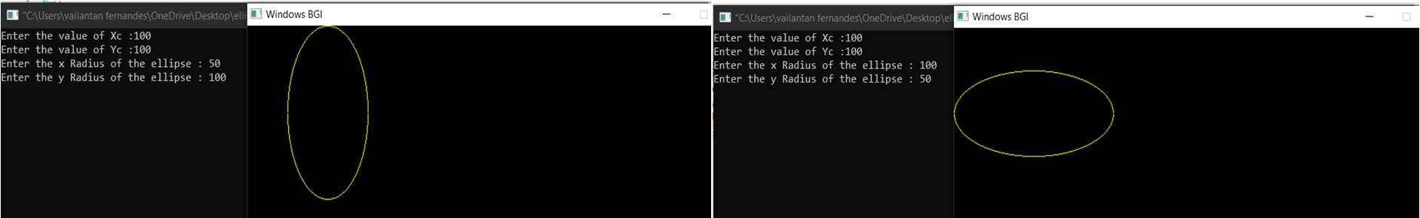

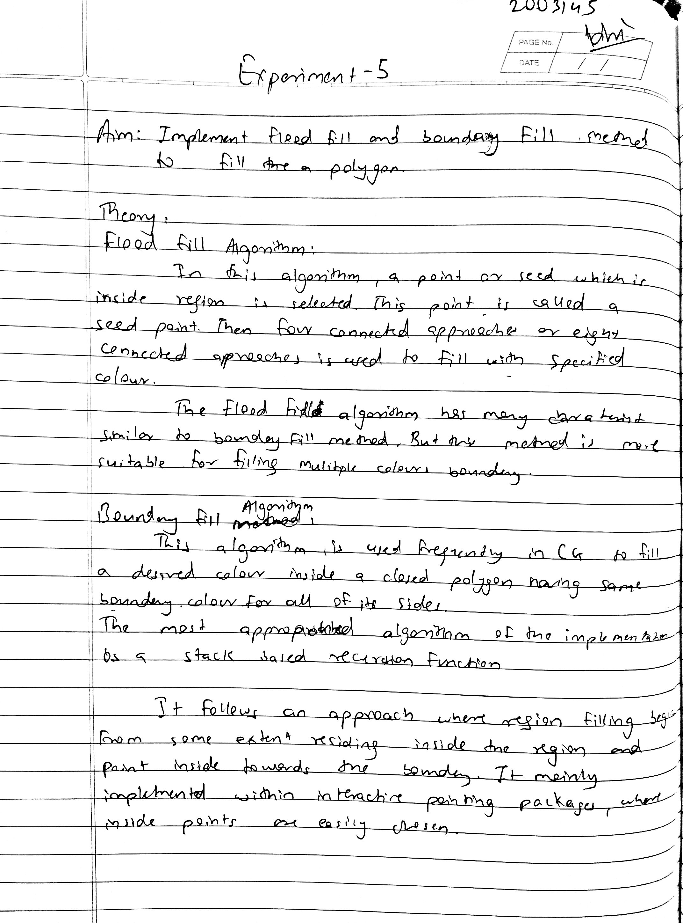

**Flood fill**

**Program :**

#include <stdio.h>

#include <graphics.h>

#include <dos.h>

void flood(int x, int y, int newcolor, int oldcolor)

{

    if (getpixel(x, y) == oldcolor)

    {

        putpixel(x, y, newcolor);

        flood(x + 1, y, newcolor, oldcolor);

        flood(x, y + 1, newcolor, oldcolor);

        flood(x - 1, y, newcolor, oldcolor);

        flood(x, y - 1, newcolor, oldcolor);

    }

    delay(2);

}

int main()

{

    int gm, gd = DETECT, radius;

    int x, y, l, b;

    clrscr();

    initgraph(&gd, &gm, "c:\\Turboc3\\bgi");

    printf("Enter the coordinates of the first vertice: \n");

    printf("x: ");

    scanf("%d", &x);

    printf("y: ");

    scanf("%d", &y);

    printf("Enter the length and the breadth of the rectangle: \n");

    printf("length: ");

    scanf("%d", &l);

    printf("breadth: ");

    scanf("%d", &b);

    rectangle(x, y, x + b, y + l);

    flood(x + 1, y + 1, YELLOW, 0);

    closegraph();

    getch();

    return 0;

}

**Output :**

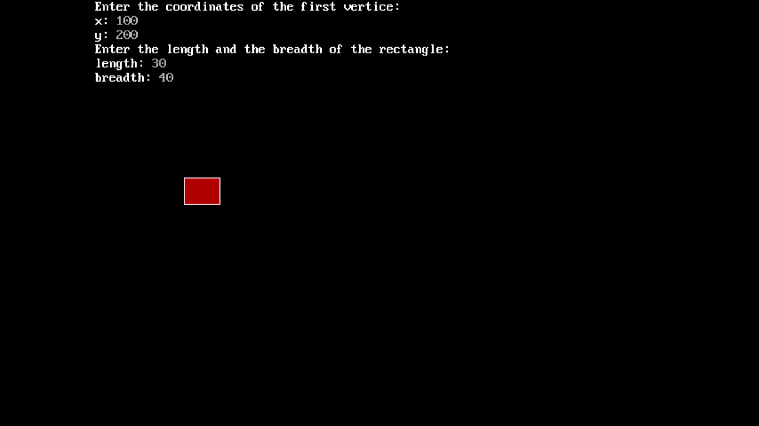

Boundary Fill :

**Program :**

#include <graphics.h>

#include <conio.h>

void boundaryFill8(int x, int y, int fill_color, int boundary_color)

{

    if (getpixel(x, y) != boundary_color &&

        getpixel(x, y) != fill_color)

    {

        putpixel(x, y, fill_color);

        boundaryFill8(x + 1, y, fill_color, boundary_color);

        boundaryFill8(x, y + 1, fill_color, boundary_color);

        boundaryFill8(x - 1, y, fill_color, boundary_color);

        boundaryFill8(x, y - 1, fill_color, boundary_color);

        boundaryFill8(x - 1, y - 1, fill_color, boundary_color);

        boundaryFill8(x - 1, y + 1, fill_color, boundary_color);

        boundaryFill8(x + 1, y - 1, fill_color, boundary_color);

        boundaryFill8(x + 1, y + 1, fill_color, boundary_color);

    }

}

void main()

{

    int gd = DETECT, gm, x, y, l, b;

    clrscr();

    initgraph(&gd, &gm, "c:\\Turboc3\\bgi");

    printf("Enter the coordinates of the first vertice: \n");

    printf("x: ");

    scanf("%d", &x);

    printf("y: ");

    scanf("%d", &y);

    printf("Enter the length and the breadth of the rectangle: \n");

    printf("length: ");

    scanf("%d", &l);

    printf("breadth: ");

    scanf("%d", &b);

    rectangle(x, y, x + b, y + l);

    boundaryFill8(x + 1, y + 1, YELLOW, 15);

    getch();

    closegraph();

}

**Output :**

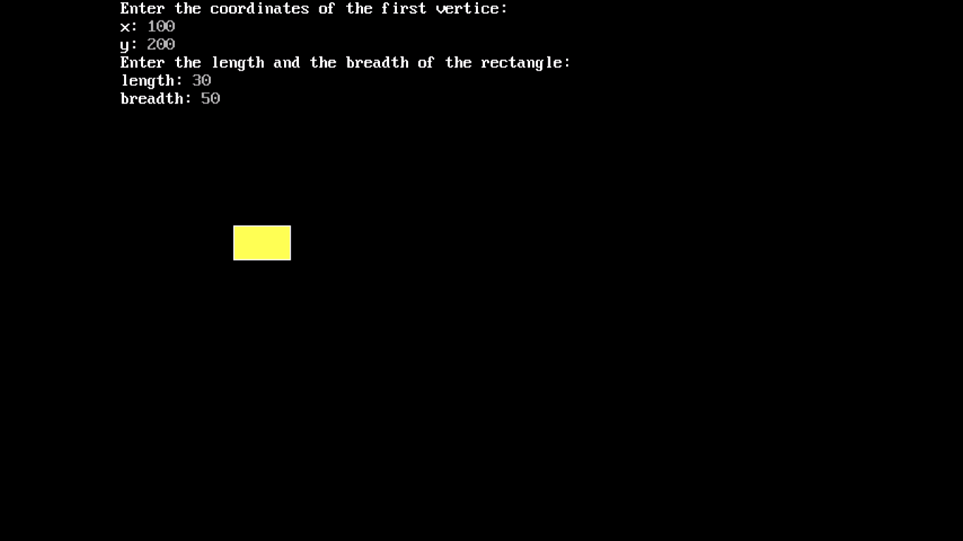

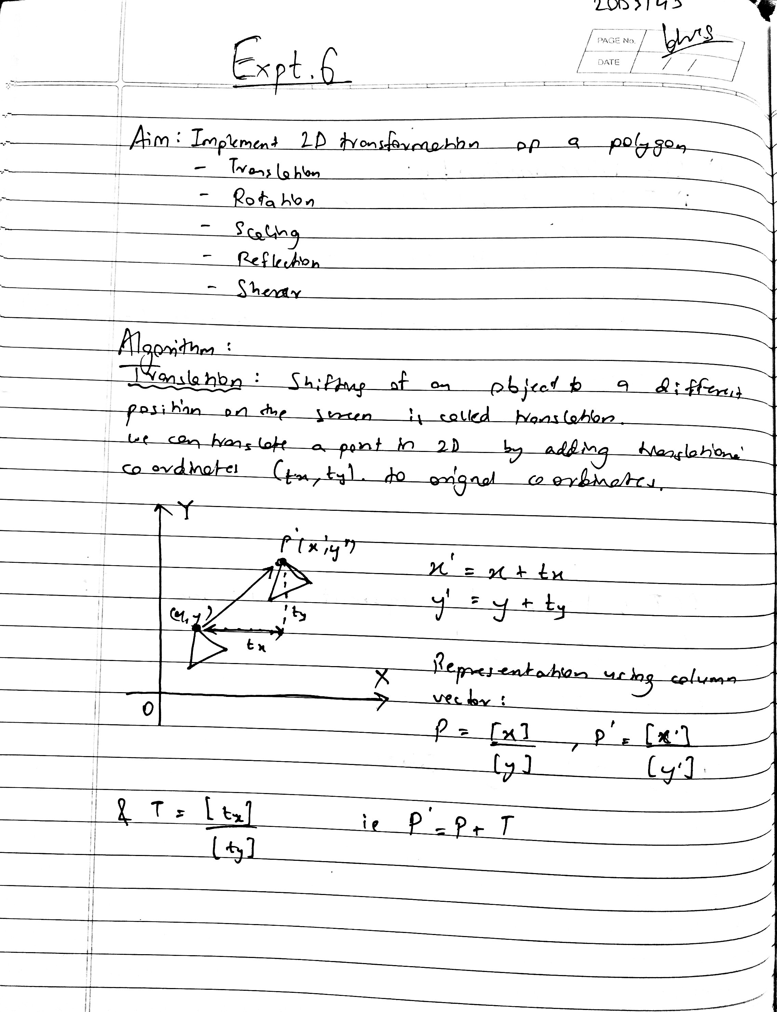

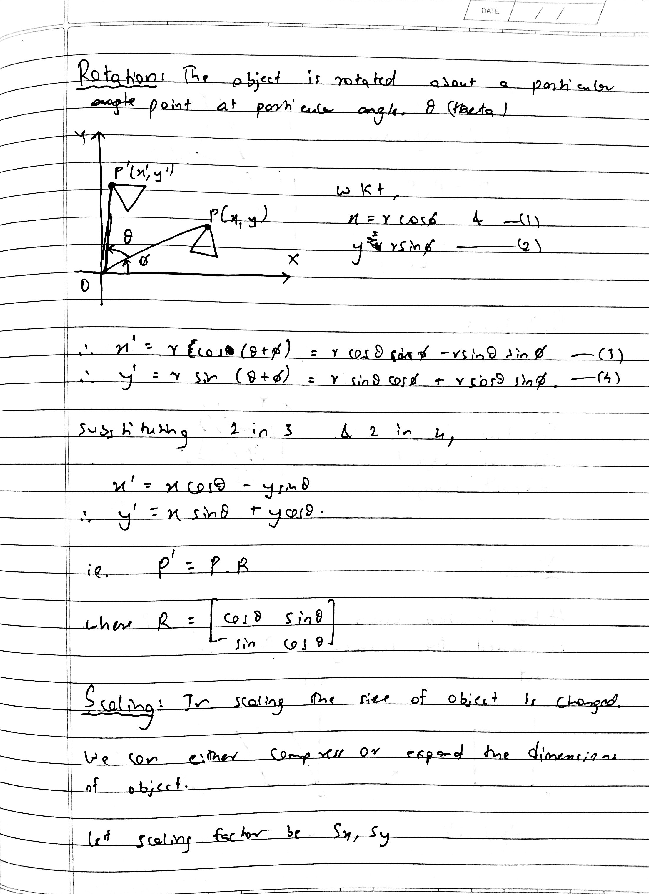

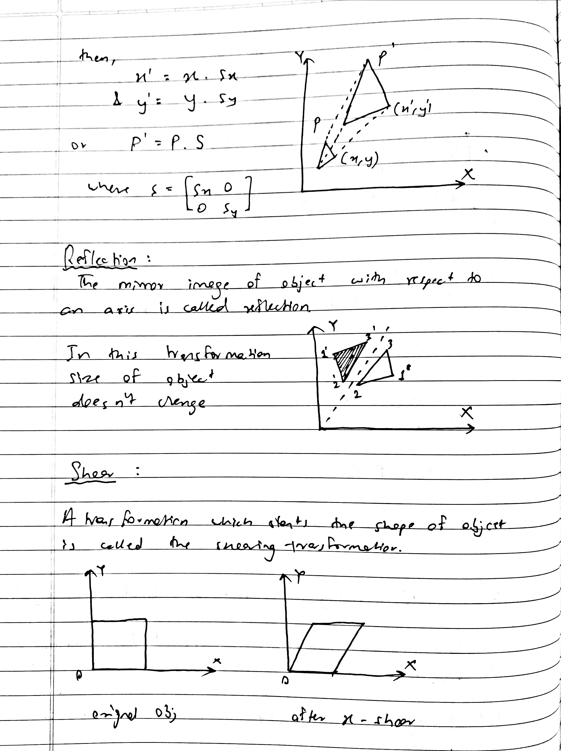

**Program :**

#include <stdio.h>

#include <stdlib.h>

#include <conio.h>

#include <math.h>

#include <graphics.h>

int options()

{

    int choice;

 printf("\n1.Translation\n2.Scaling\n3.Rotation\n4.Reflection\n5.

Shearing");

 printf("\nEnter your choice [1 - 5]: ");

 scanf("%d",&choice);

 return choice;

}

void draw(float D[3][3])

{

    line(320 + D[0][0], 240 - D[0][1], 320 + D[1][0], 240 - D[1][1]);

    line(320 + D[1][0], 240 - D[1][1], 320 + D[2][0], 240 - D[2][1]);

    line(320 + D[2][0], 240 - D[2][1], 320 + D[0][0], 240 - D[0][1]);

}

void print(float A[3][3])

{

    int i, j;

    for (i = 0; i < 3; i++)

    {

        for (j = 0; j < 3; j++)

        {

            printf("%0.2f\t", A[i][j]);

        }

        printf("\n");

    }

}

void multiply(float B[3][3], float C[3][3], float D[3][3])

{

    int i, j, k;

    float s = 0.0;

    for (i = 0; i < 3; i++)

    {

        for (j = 0; j < 3; j++)

        {

            s = 0.0;

            for (k = 0; k < 3; k++)

            {

                s = s + (B[i][k] * C[k][j]);

            }

            D[i][j] = s;

        }

    }

}

void main()

{

    int gd = DETECT, gm;

    int i, j, k, choice;

    float x1, y1, x2, y2, x3, y3, obj[3][3], T[3][3], S[3][3], R[3][3], Sh[3][3], r[3][3];

    initgraph(&gd, &gm, "C:\\TURBOC3\\BGI");

    line(0, 240, 640, 240);

    line(320, 0, 320, 480);

    printf("\nEnter the coordinates of Polygon:\n");

    printf("\nEnter first coordinates x1 and y1: \t");

    scanf("%f%f", &x1, &y1);

    printf("Enter second coordinates x2 and y2:\t");

    scanf("%f%f", &x2, &y2);

    printf("Enter third coordinates x3 and y3: \t");

    scanf("%f%f", &x3, &y3);

    line(320 + x1, 240 - y1, 320 + x2, 240 - y2);

    line(320 + x2, 240 - y2, 320 + x3, 240 - y3);

    line(320 + x3, 240 - y3, 320 + x1, 240 - y1);

    obj[0][0] = x1;

    obj[0][1] = y1;

    obj[1][0] = x2;

    obj[1][1] = y2;

    obj[2][0] = x3;

    obj[2][1] = y3;

    obj[0][2] = 1;

    obj[1][2] = 1;

    obj[2][2] = 1;

    printf("\nObject matrix is: \n");

    print(obj);

    switch (options())

    {

    case 1:

    {

        float tx, ty, trans[3][3];

        printf("\nEnter values for tx and ty: ");

        scanf("%f%f", &tx, &ty);

        for (i = 0; i < 3; i++)

        {

            for (j = 0; j < 3; j++)

            {

                if (i == j)

                    trans[i][j] = 1;

                else

                    trans[i][j] = 0;

            }

        }

        trans[2][0] = tx;

        trans[2][1] = ty;

        printf("\nTranslation matrix: \n");

        print(trans);

        multiply(obj, trans, T);

        printf("\nOutput matrix: \n");

        print(T);

        draw(T);

    }

    break;

    case 2:

    {

        float scale[3][3], sx, sy;

        printf("\nEnter values for sx and sy: ");

        scanf("%f%f", &sx, &sy);

        for (i = 0; i < 3; i++)

        {

            for (j = 0; j < 3; j++)

            {

                scale[i][j] = 0;

            }

        }

        scale[0][0] = sx;

        scale[1][1] = sy;

        scale[2][2] = 1;

        printf("\nScaling matrix: \n");

        print(scale);

        multiply(obj, scale, S);

        printf("\nOutput matrix: \n");

        print(S);

        draw(S);

    }

    break;

    case 3:

    {

        float rotate[3][3], theta;

        printf("\nEnter the angle in degree: ");

        scanf("%f", &theta);

        theta = theta * (3.14 / 180);

        rotate[0][0] = cos(theta);

        rotate[1][1] = cos(theta);

        rotate[0][2] = 0;

        rotate[1][2] = 0;

        rotate[2][0] = 0;

        rotate[2][1] = 0;

        rotate[2][2] = 1;

        rotate[0][1] = sin(theta);

        rotate[1][0] = -sin(theta);

        printf("\nRotation matrix: \n");

        print(rotate);

        multiply(obj, rotate, r);

        printf("\nOuput matrix: \n");

        print(r);

        draw(r);

    }

    break;

    case 4:

    {

        float ref[3][3];

        for (i = 0; i < 3; i++)

        {

            for (j = 0; j < 3; j++)

            {

                if (i == j)

                    ref[i][j] = 1;

                else

                    ref[i][j] = 0;

            }

        }

        ref[0][0] = ref[1][1] = -1;

        printf("\nReflection matrix: \n");

        print(ref);

        multiply(obj, ref, R);

        printf("\nOutput matrix: \n");

        print(R);

        draw(R);

    }

    break;

    case 5:

    {

        float shear[3][3], shx, shy;

        printf("\nEnter shx and shy: \n");

        scanf("%f%f", &shx, &shy);

        for (i = 0; i < 3; i++)

        {

            for (j = 0; j < 3; j++)

            {

                if (i == j)

                    shear[i][j] = 1;

                else

                    shear[i][j] = 0;

            }

        }

        shear[0][1] = shy;

        shear[1][0] = shx;

        printf("\nShearing matrix: \n");

        print(shear);

        multiply(obj, shear, Sh);

        printf("Output matrix: \n");

        print(Sh);

        draw(Sh);

    }

    break;

    default:

        printf("\nInvalid choice!");

    }

    getch();

}

**Output :**

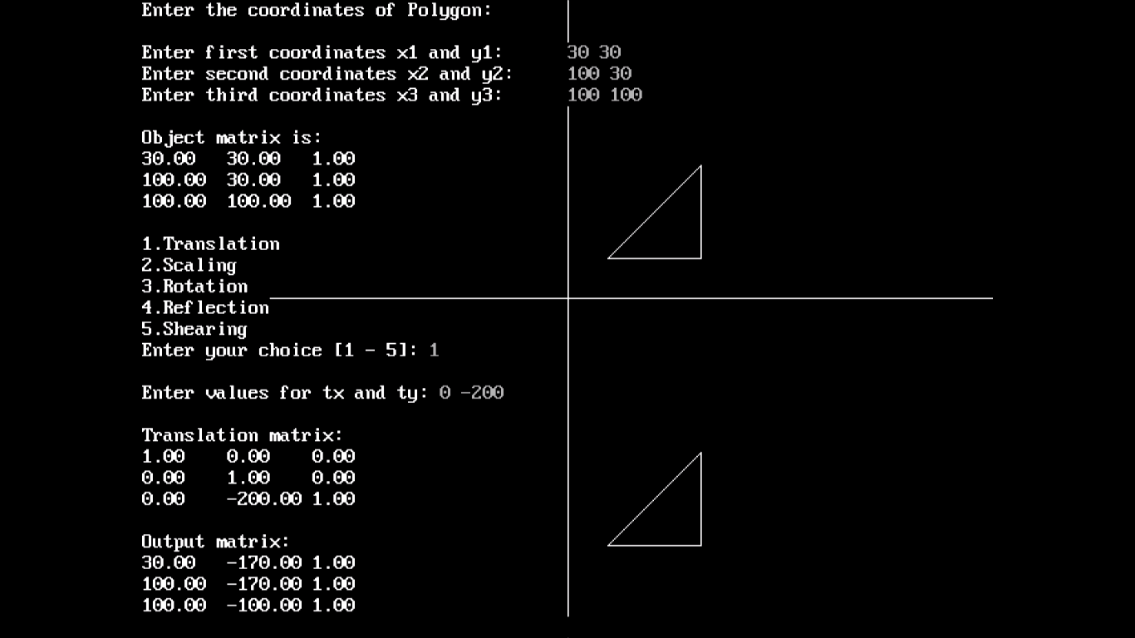

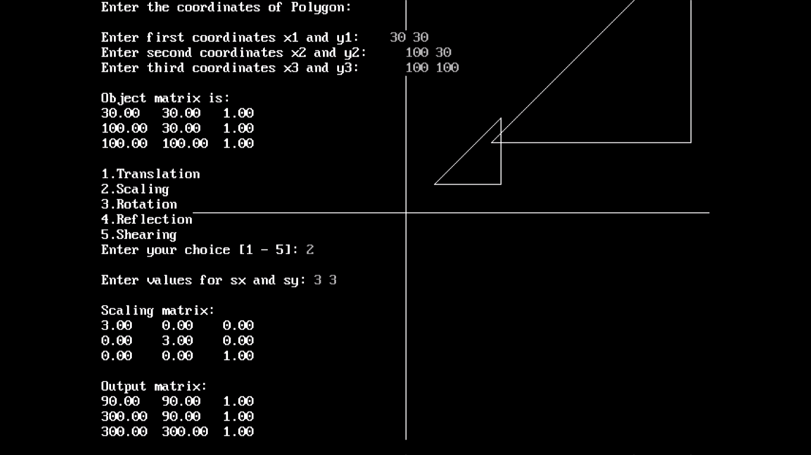

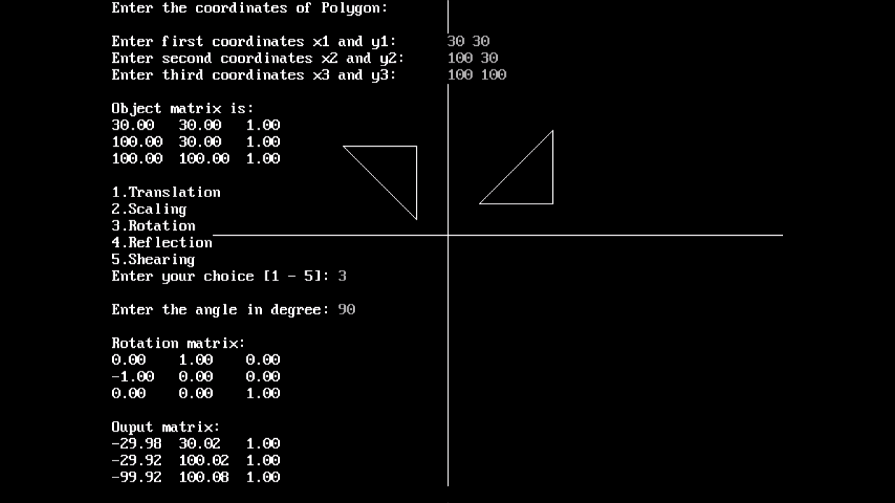

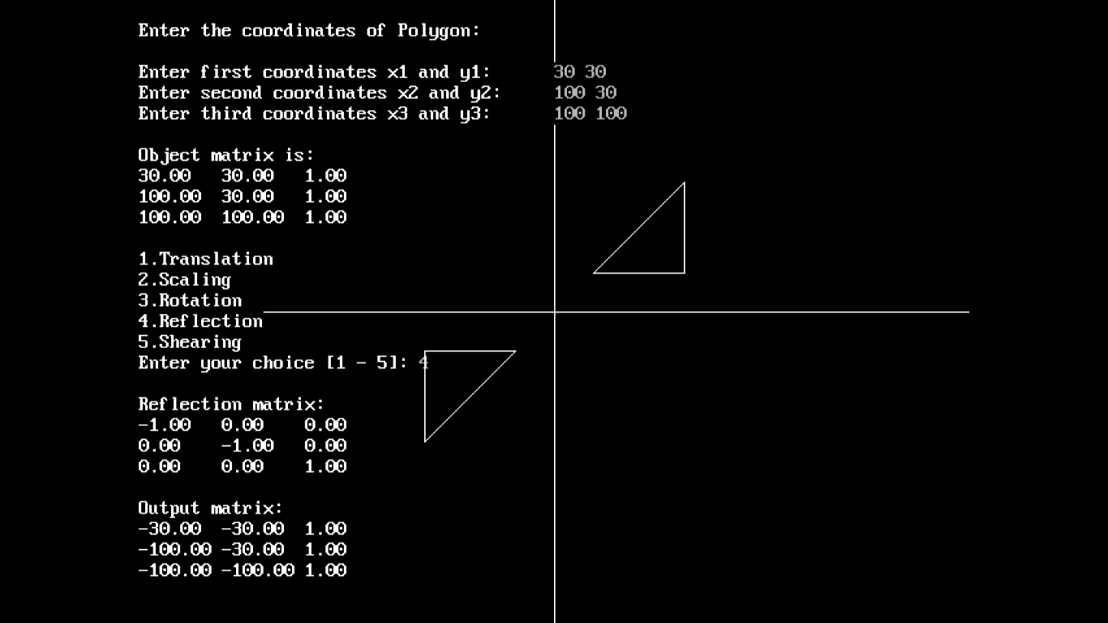

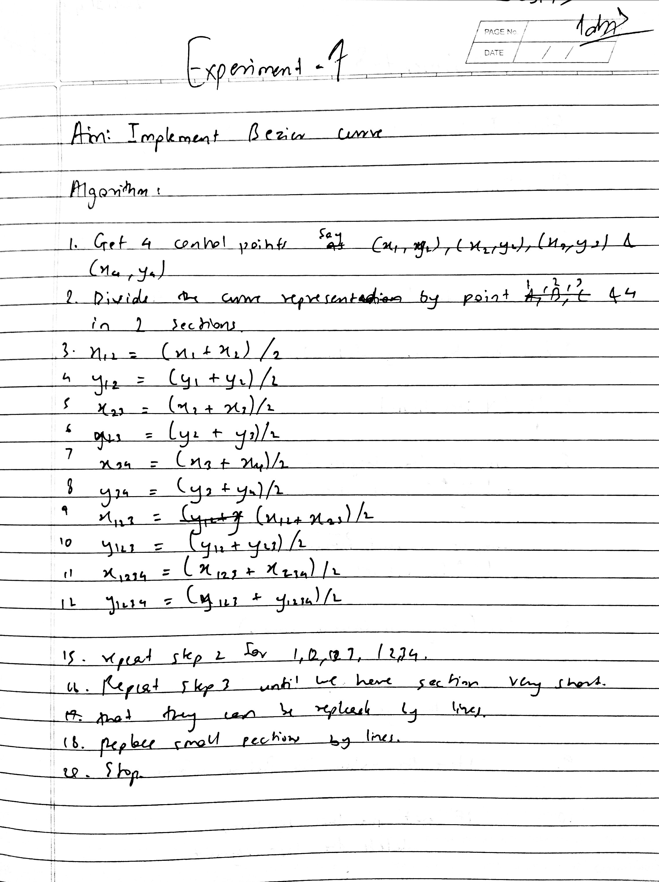

**Program :**

#include <stdio.h>

#include <graphics.h>

#include <math.h>

void main()

{

    int gd = DETECT, gm, i;

    double A, B, u;

    int x[10], y[10],n;

    printf("Enter n : ");

    scanf("%d",&n);

    initgraph(&gd, &gm, "C:\\TURBOC3\\BGI");

    for (i = 0; i < n; i++)

    {

        printf("\nEnter x y: ");

        scanf("%d%d", &x[i], &y[i]);

    }

    for (u = 0.0; u <= 1.0; u += 0.0005)

    {

        A = x[0] * pow((1 - u), 3) + x[1] * 3 * u * pow((1 - u), 2) + x[2] * 3 * pow(u, 2) * (1 - u) + x[3] * pow(u, 3);

        B = y[0] * pow((1 - u), 3) + y[1] * 3 * u * pow((1 - u), 2) + y[2] * 3 * pow(u, 2) * (1 - u) + y[3] * pow(u, 3);

        putpixel(A, B, WHITE);

    }

    getch();

}

**Output :**

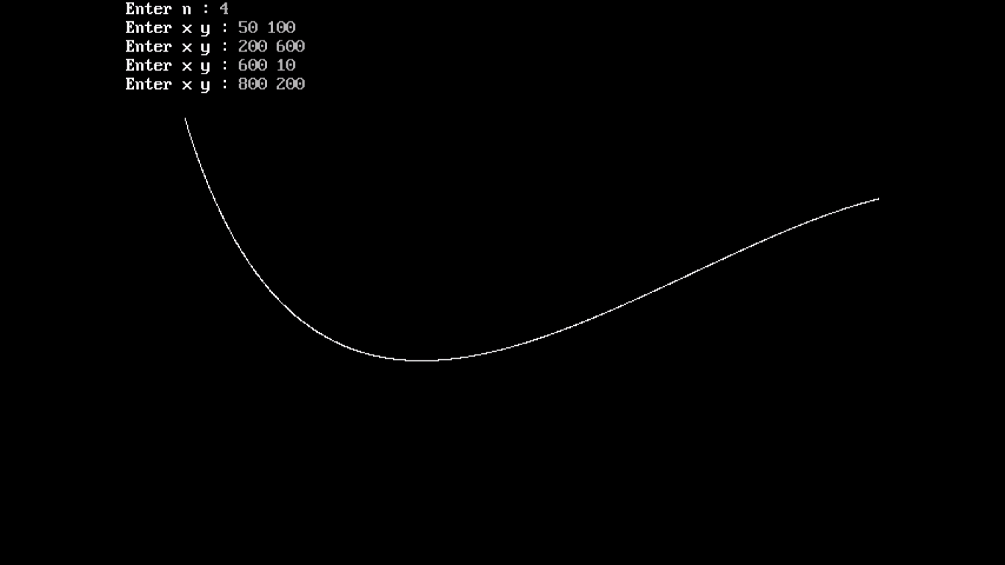

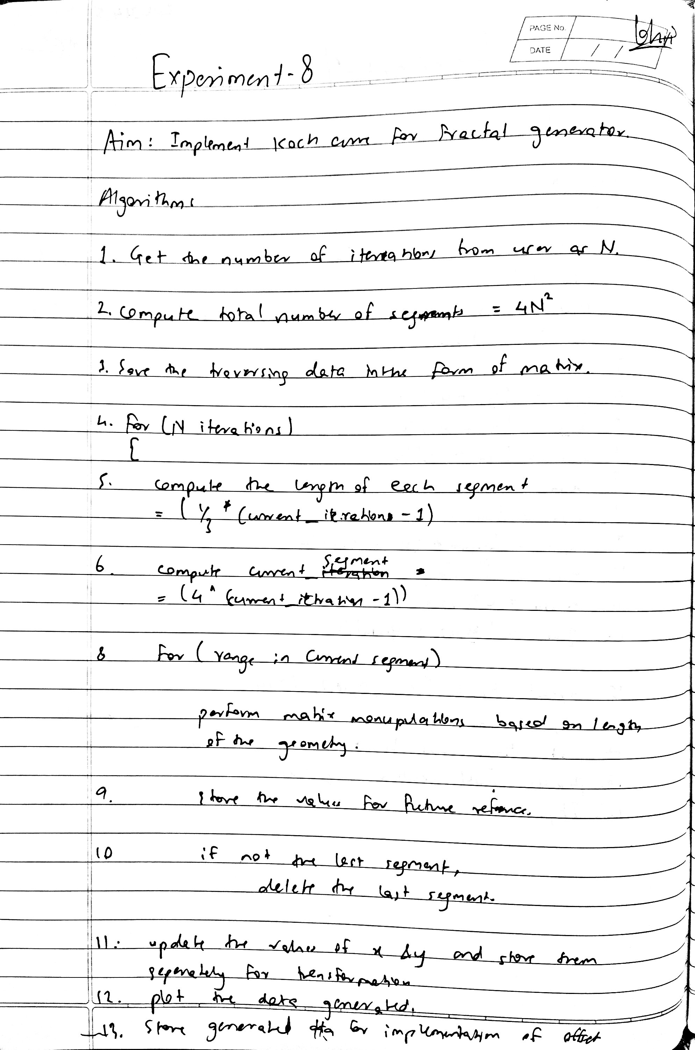

**Program :**

#include <graphics.h>

#include <conio.h>

#include <math.h>

void koch(int x1, int y1, int x2, int y2, int it)

{

    float angle = 60 * M_PI / 180;

    int x3 = (2 * x1 + x2) / 3;

    int y3 = (2 * y1 + y2) / 3;

    int x4 = (x1 + 2 * x2) / 3;

    int y4 = (y1 + 2 * y2) / 3;

    int x = x3 + (x4 - x3) * cos(angle) + (y4 - y3) * sin(angle);

    int y = y3 - (x4 - x3) * sin(angle) + (y4 - y3) * cos(angle);

    if (it > 0)

    {

        koch(x1, y1, x3, y3, it - 1);

        koch(x3, y3, x, y, it - 1);

        koch(x, y, x4, y4, it - 1);

        koch(x4, y4, x2, y2, it - 1);

    }

    else

    {

        line(x1, y1, x3, y3);

        line(x3, y3, x, y);

        line(x, y, x4, y4);

        line(x4, y4, x2, y2);

    }

}

int main(void)

{

    int gd = DETECT, gm;

    int x1, y1, x2, y2, n;

    initgraph(&gd, &gm, "C:\\TURBOC3\\BGI");

    printf("\nEnter the coordinates of x1,y1,x2,y2 : ");

    scanf("%d%d%d%d", &x1, &y1, &x2, &y2);

    printf("\nEnter the number of iteration: ");

    scanf("%d", &n);

    koch(x1, y1, x2, y2, n);

    getch();

    return 0;

}

**Output :**

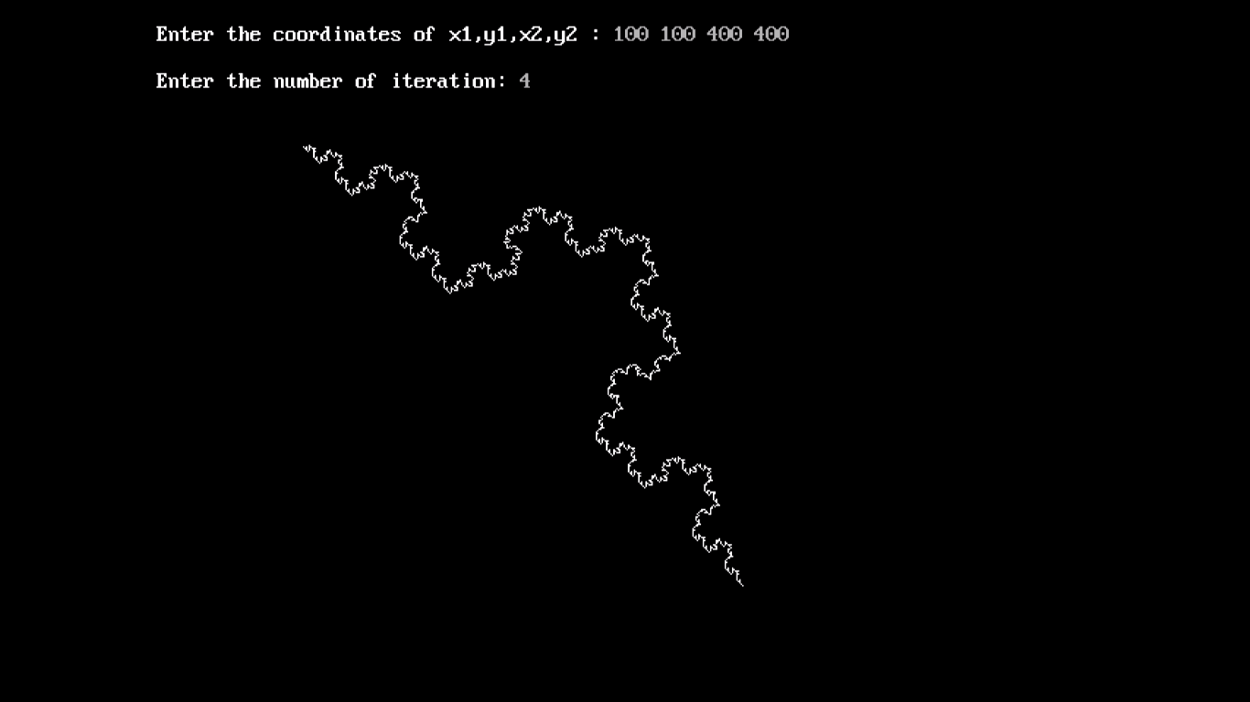

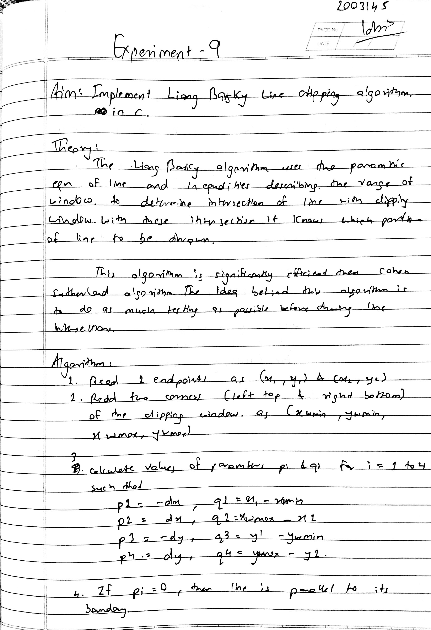

**Program :**

#include <stdio.h>

#include <graphics.h>

#include <math.h>

#include <dos.h>

void window(int, int, int, int);

void linedraw(int, int, int, int, int, int, int, int);

void main()

{

    int gd = DETECT, gm;

    int x1, y1, x2, y2, xmin, xmax, ymin, ymax;

    initgraph(&gd, &gm, "C:\\TURBOC3\\BGI");

    cleardevice();

    printf("Enter the coordinates of x1, y1, x2, y2 : ");

    scanf("%d%d%d%d", &x1, &y1, &x2, &y2);

    printf("\nEnter the coordinates of xmin, ymin, xmax, ymax : ");

    scanf("%d%d%d%d", &xmin, &ymin, &xmax, &ymax);

    window(xmin, ymin, xmax, ymax);

    linedraw(x1, x2, y1, y2, xmin, xmax, ymin, ymax);

    getch();

    closegraph();

}

void window(int xmin, int ymin, int xmax, int ymax)

{

    rectangle(xmin, ymin, xmax, ymax);

    printf("Please a key to see the clipped line...");

    getch();

}

void linedraw(int x1, int x2, int y1, int y2, int xmin, int xmax, int ymin, int ymax)

{

    int a, b, i;

    float p[4], q[4], t1, t2, temp, xx1, xx2, yy1, yy2;

    a = x2 - x1;

    b = y2 - y1;

    p[0] = -a;

    p[1] = a;

    p[2] = -b;

    p[3] = b;

    q[0] = x1 - xmin;

    q[1] = xmax - x1;

    q[2] = y1 - ymin;

    q[3] = ymax - y1;

    for (i = 0; i < 4; i++)

    {

        if (p[i] == 0)

        {

            printf("line is parallel");

            if (q[i] >= 0)

            {

                if (i < 2)

                {

                    if (y1 < ymin)

                    {

                        y1 = ymin;

                    }

                    if (y2 > ymax)

                    {

                        y2 = ymax;

                    }

                    line(x1, y1, x2, y2);

                }

                if (i > 1)

                {

                    if (x1 < xmin)

                    {

                        x1 = xmin;

                    }

                    if (x2 > xmax)

                    {

                        x2 = xmax;

                    }

                    line(x1, y1, x2, y2);

                }

            }

        }

    }

    t1 = 0.0;

    t2 = 1.0;

    for (i = 0; i < 4; i++)

    {

        temp = q[i] / p[i];

        if (p[i] < 0)

        {

            if (t1 <= temp)

                t1 = temp;

        }

        else

        {

            if (t2 > temp)

                t2 = temp;

        }

    }

    if (t1 < t2)

    {

        xx1 = x1 + t1 * p[1];

        xx2 = x1 + t2 * p[1];

        yy1 = y1 + t1 * p[3];

        yy2 = y1 + t2 * p[3];

        line(xx1, yy1, xx2, yy2);

    }

}

**Output :**

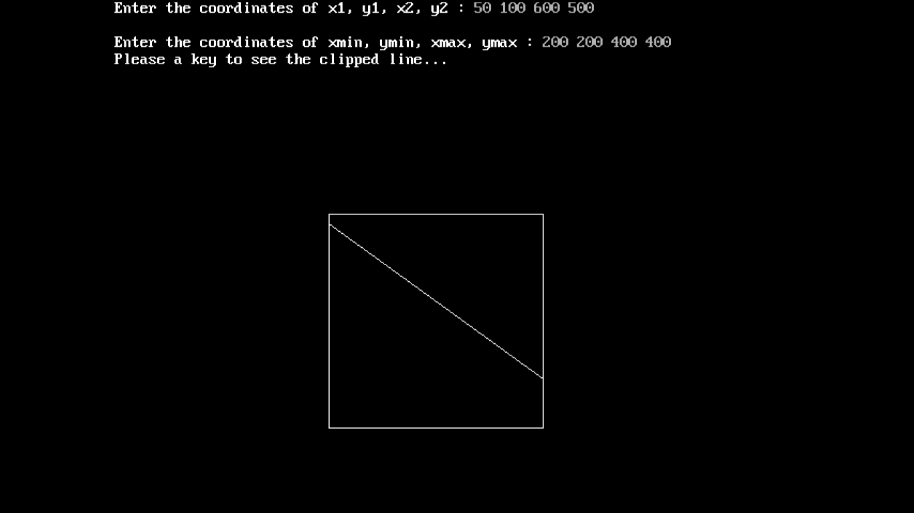

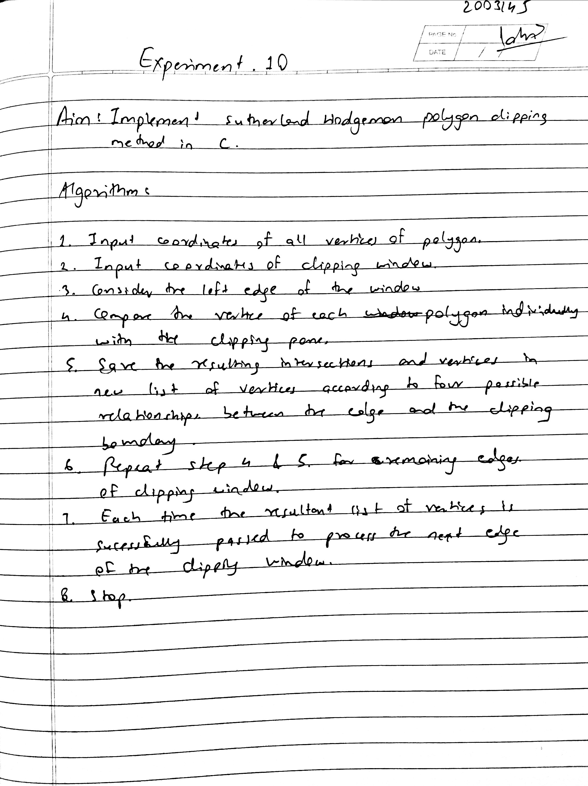

**Program :**

#include<stdio.h>

#include<graphics.h>

#include<conio.h>

#include<stdlib.h>

int main()

{

    int gd,gm,n,*x,i,k=0;

    int w[]={220,140,420,140,420,340,220,340,220,140};

    detectgraph(&gd,&gm);

    initgraph(&gd,&gm,"c:\\turboc3\\bgi");

    printf("Window:-");

    setcolor(RED);

    drawpoly(5,w);

    printf("Enter the no. of vertices of polygon: ");

    scanf("%d",&n);

    x = malloc(n*2+1);

    printf("Enter the coordinates of points:\n");

    k=0;

    for(i=0;i<n*2;i+=2)

    {

        printf("(x%d,y%d): ",k,k);

        scanf("%d,%d",&x[i],&x[i+1]);

        k++;

    }

    x[n*2]=x[0];

    x[n*2+1]=x[1];

    setcolor(WHITE);

    drawpoly(n+1,x);

    printf("\nPress a button to clip a polygon..");

    getch();

    setcolor(RED);

    drawpoly(5,w);

    setfillstyle(SOLID_FILL,BLACK);

    floodfill(2,2,RED);

    gotoxy(1,1);

    printf("\nThis is the clipped polygon..");

    getch();

    cleardevice();

    closegraph();

    return 0;

}

**Output :**

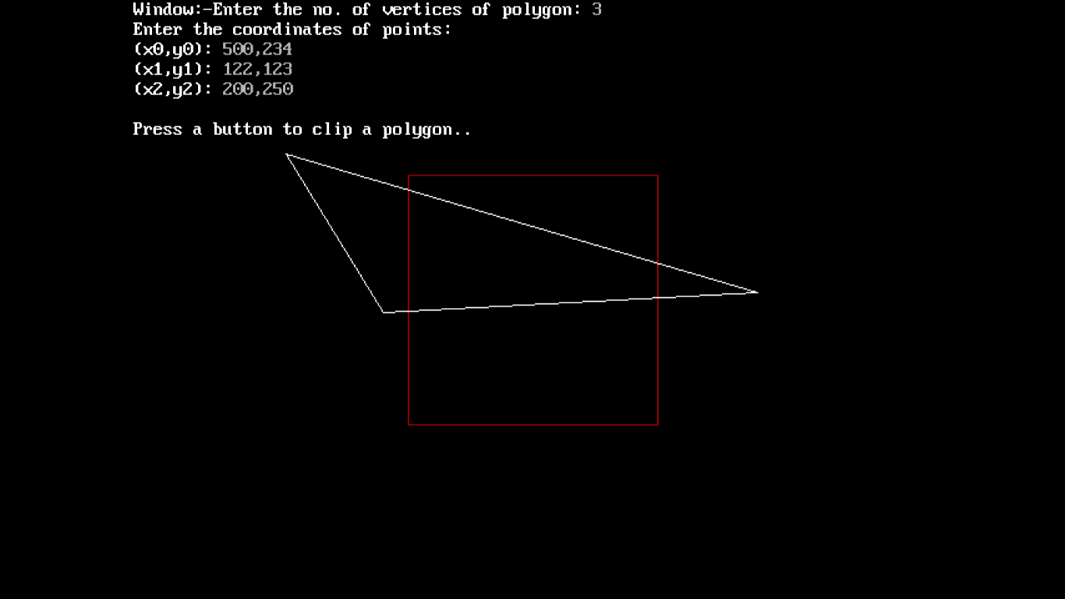

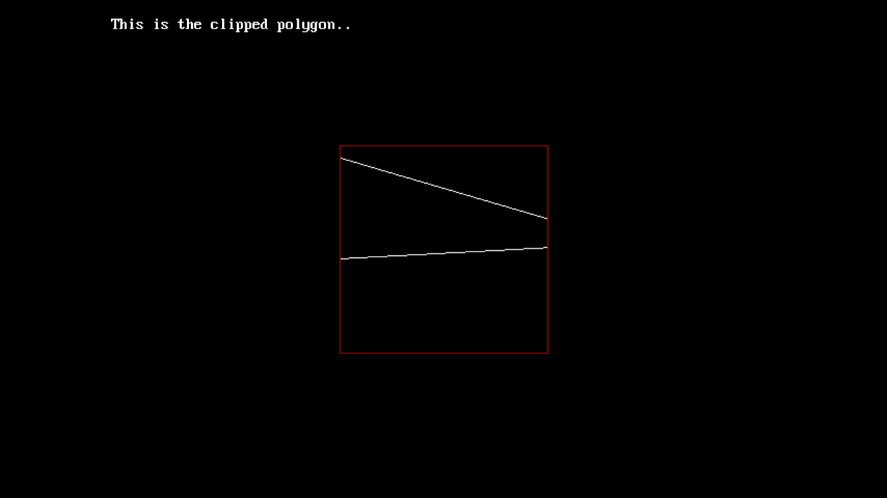

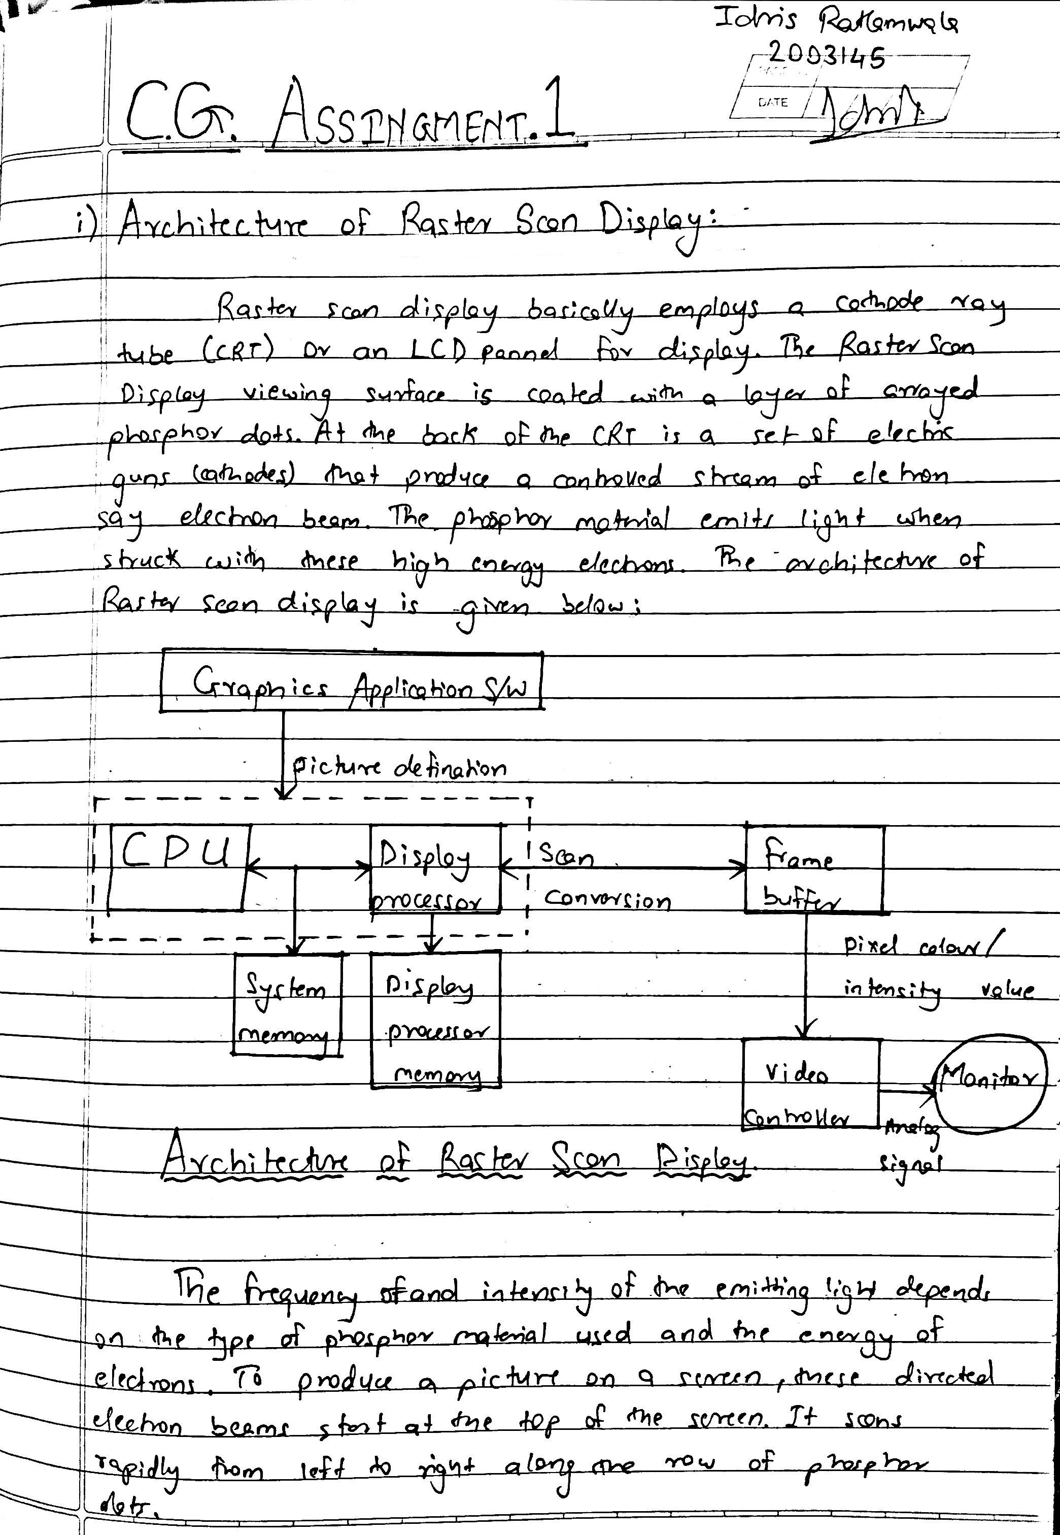

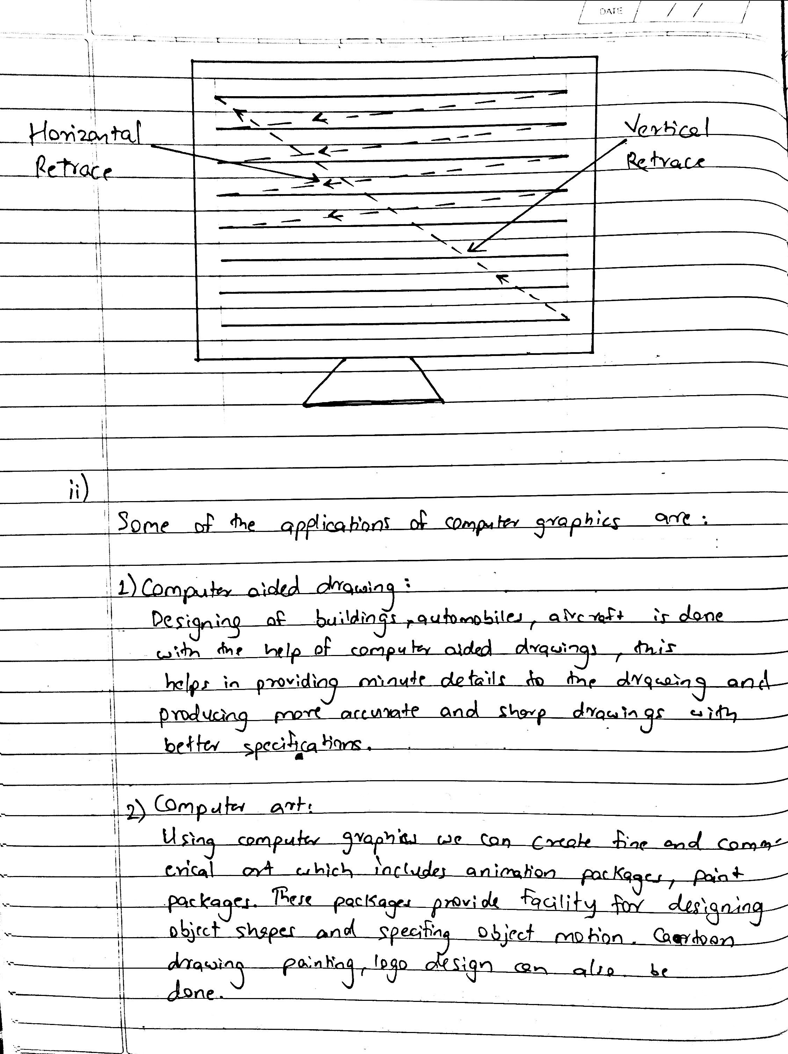

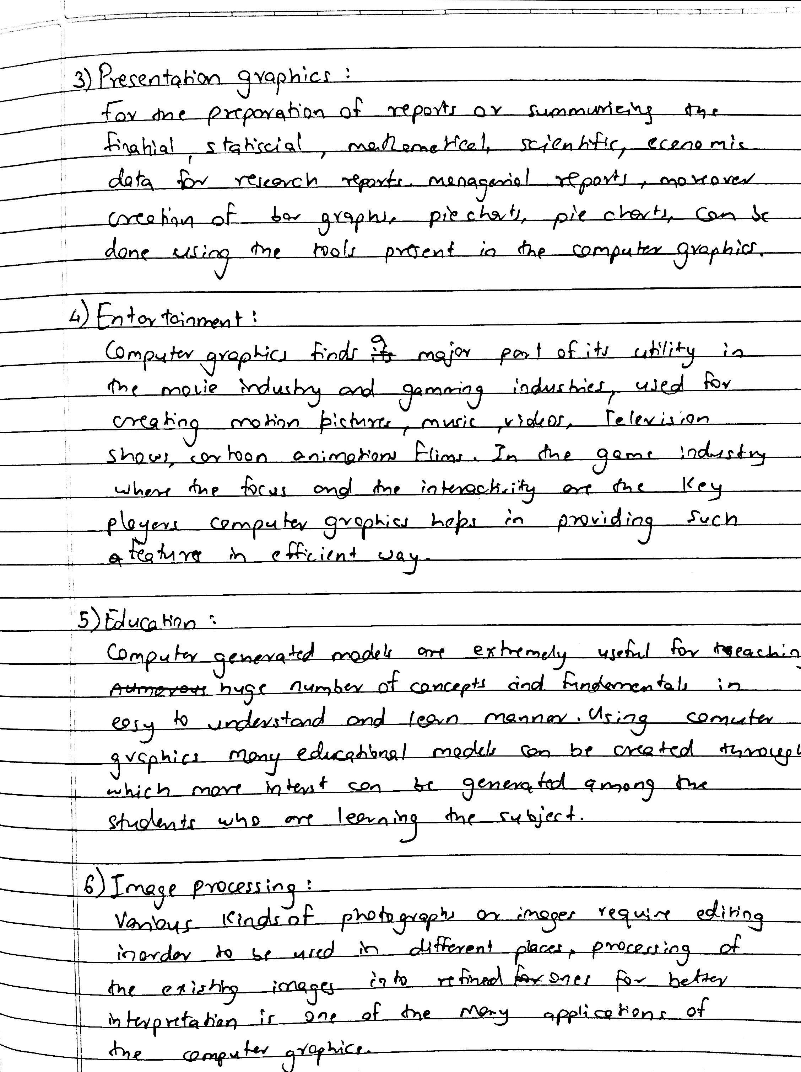

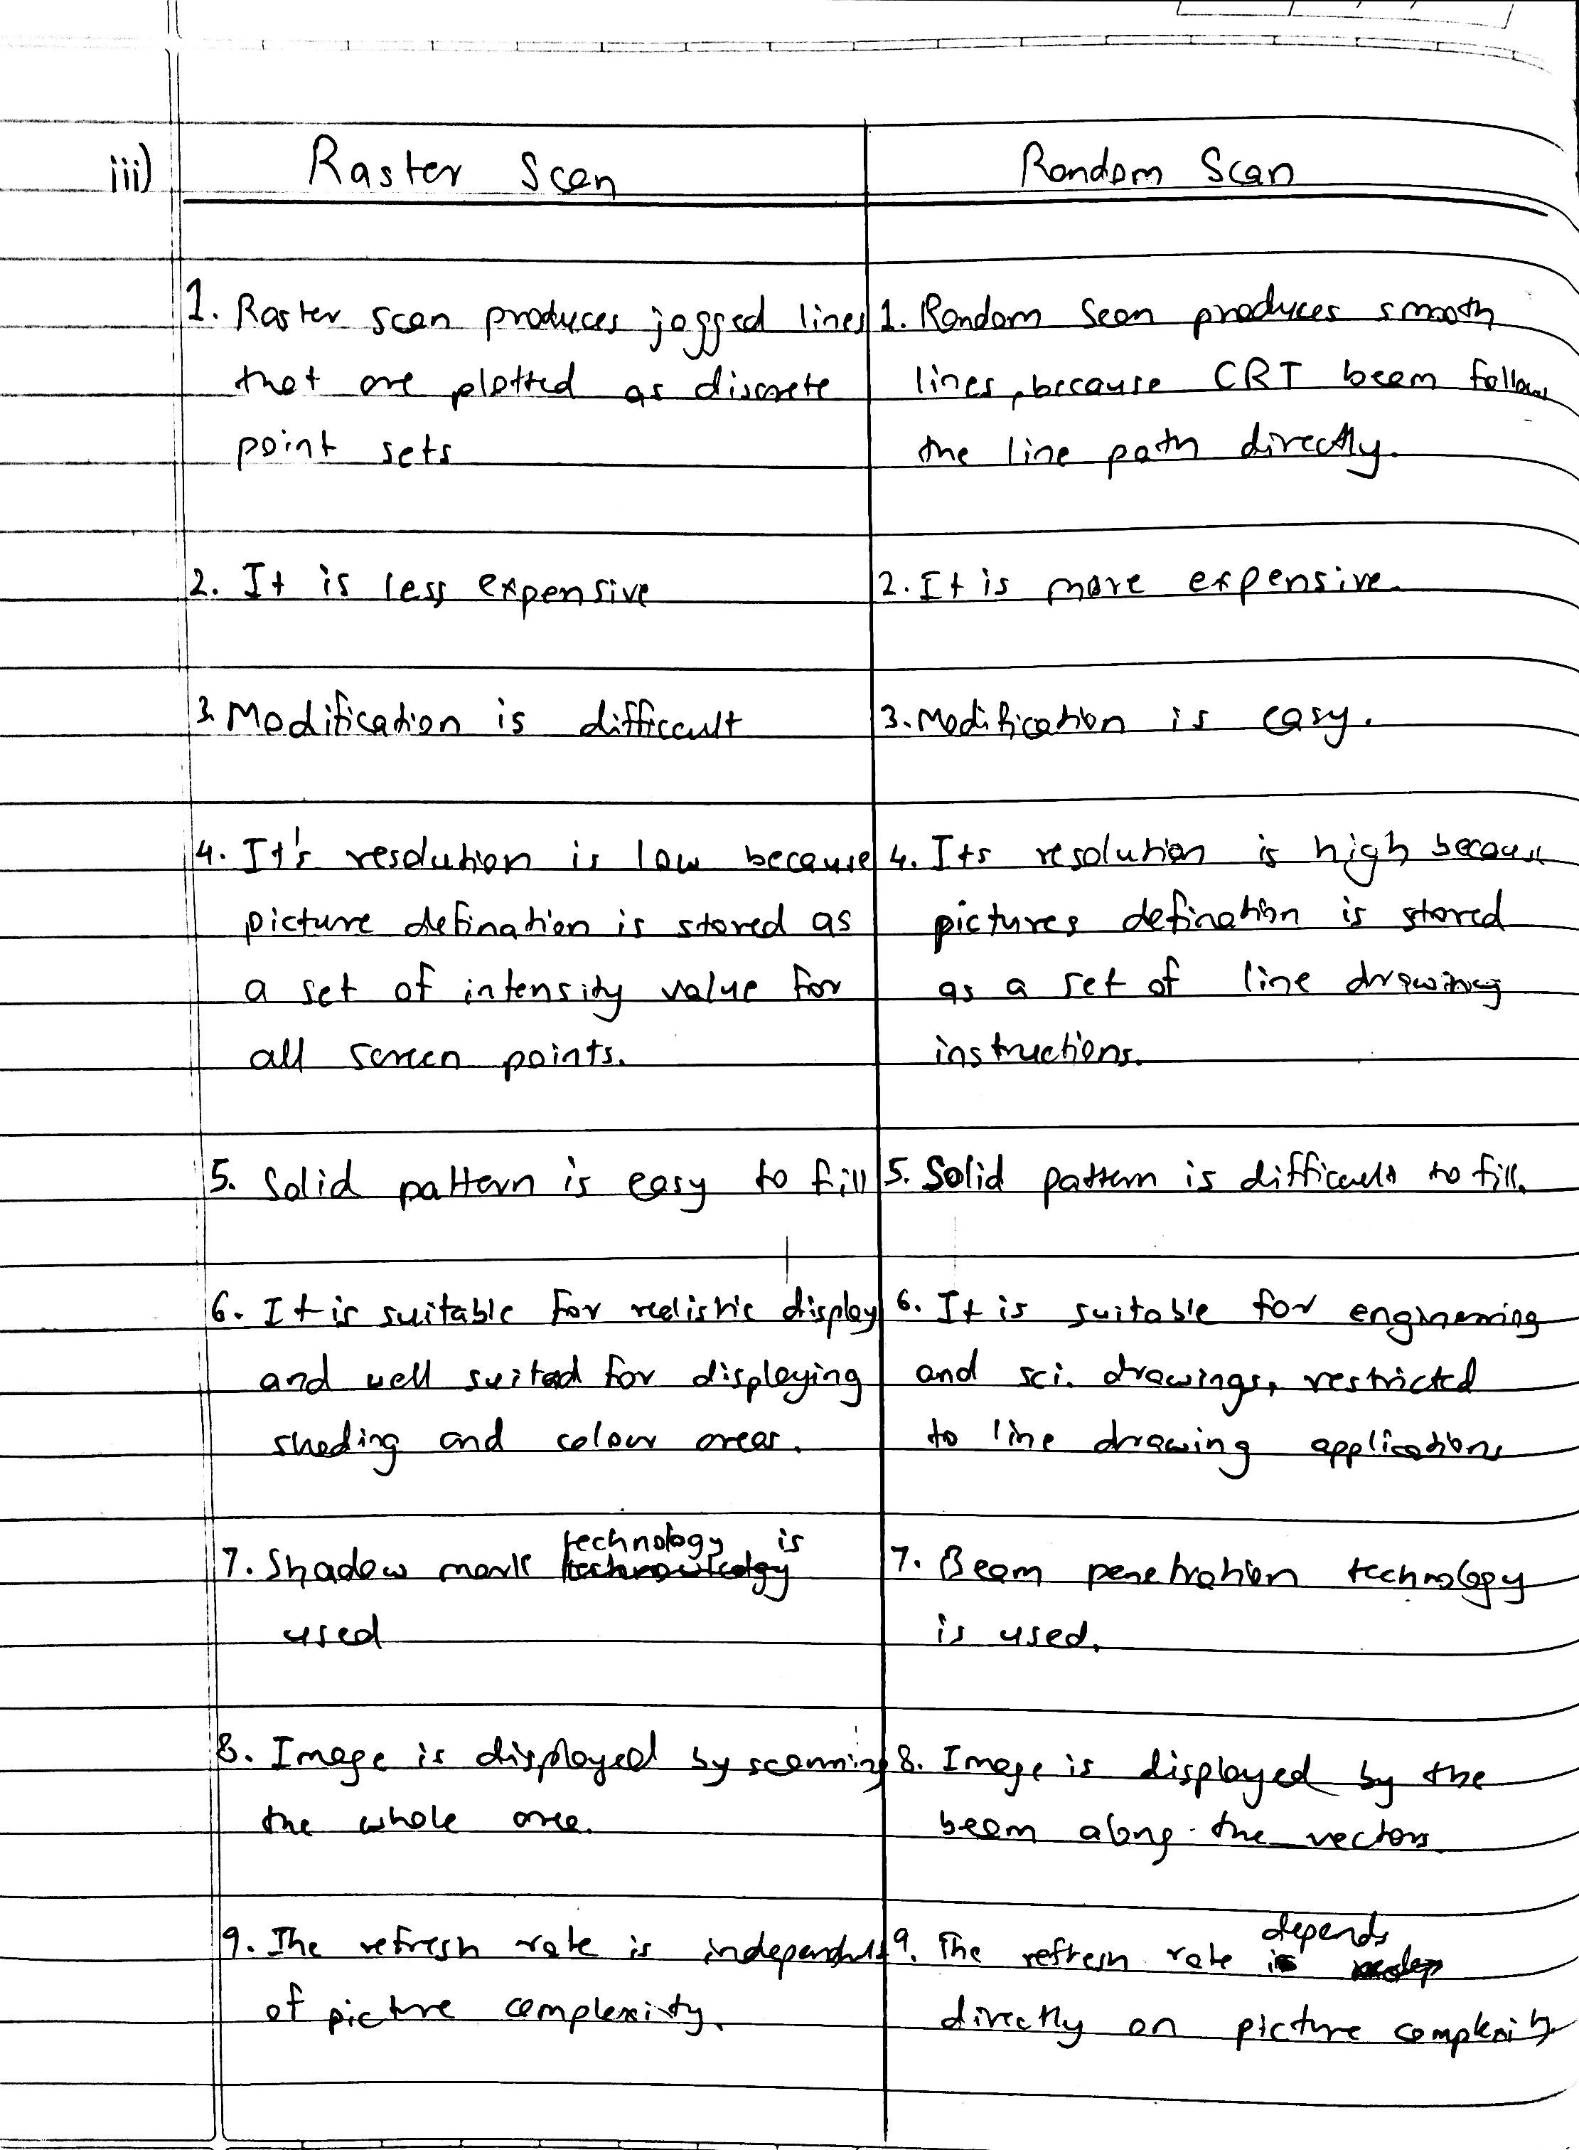

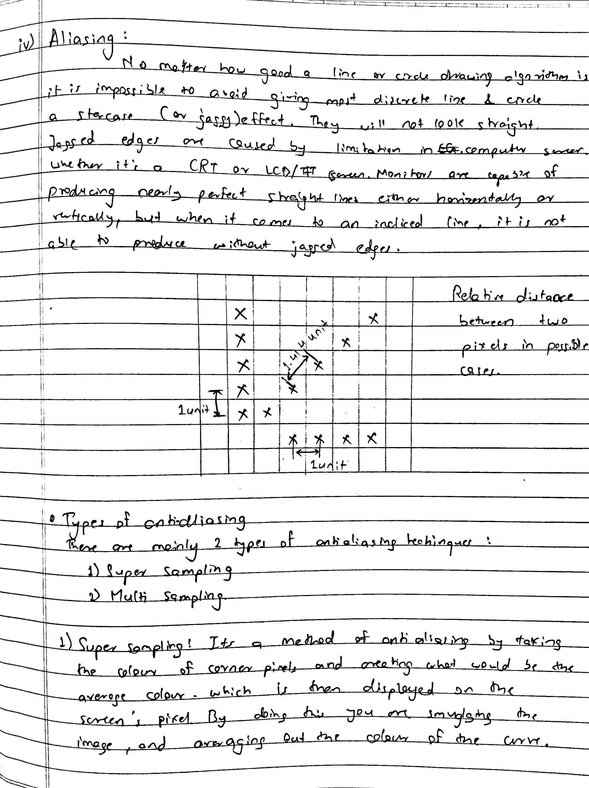

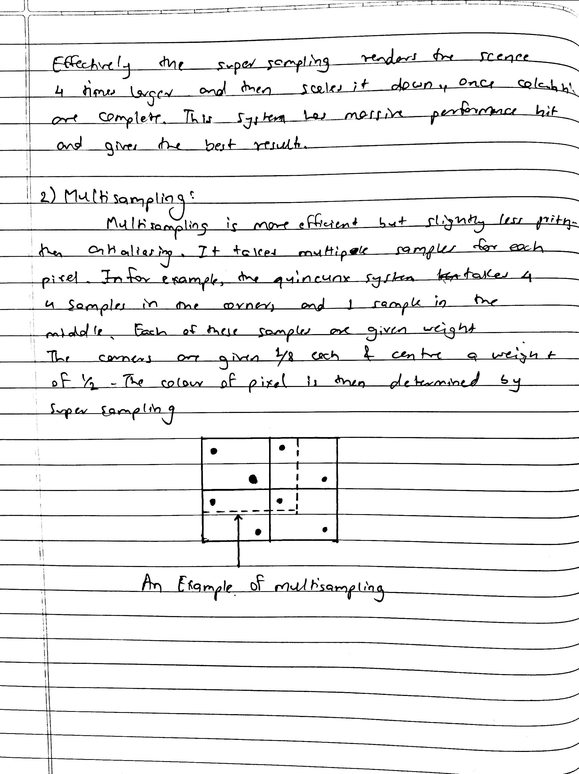

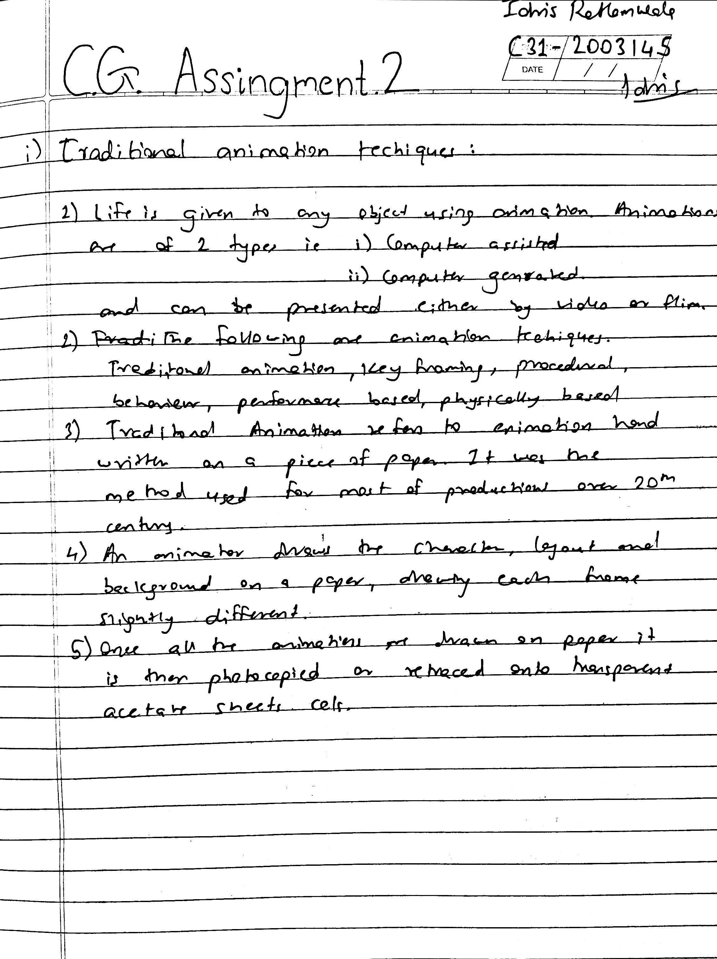

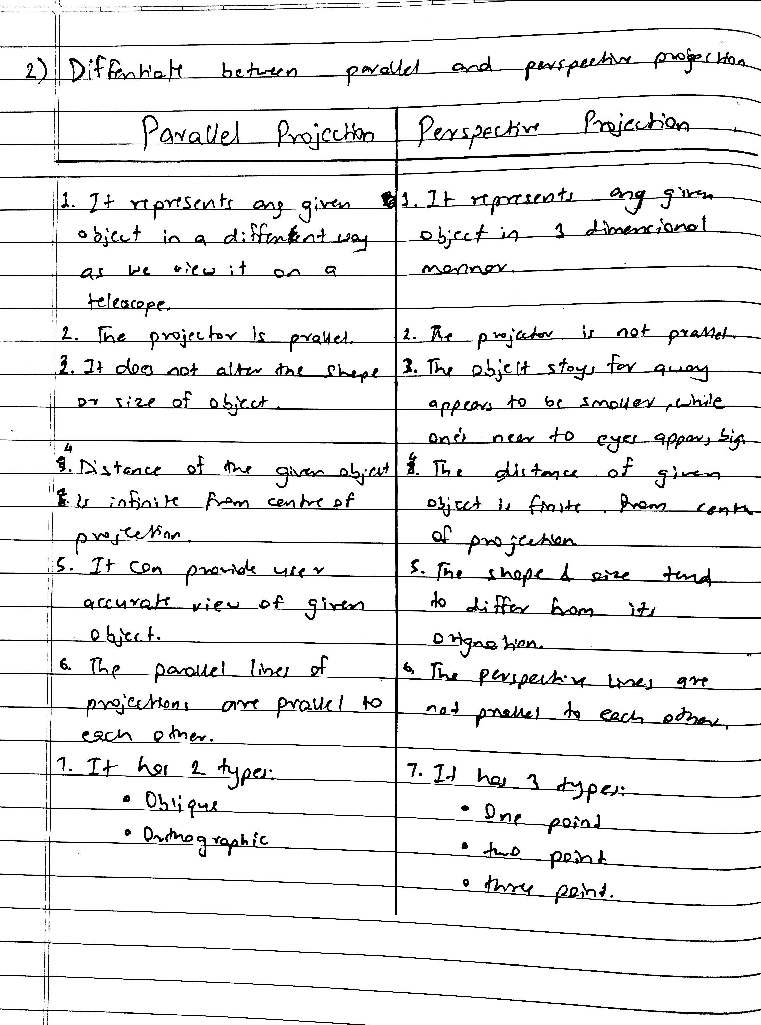

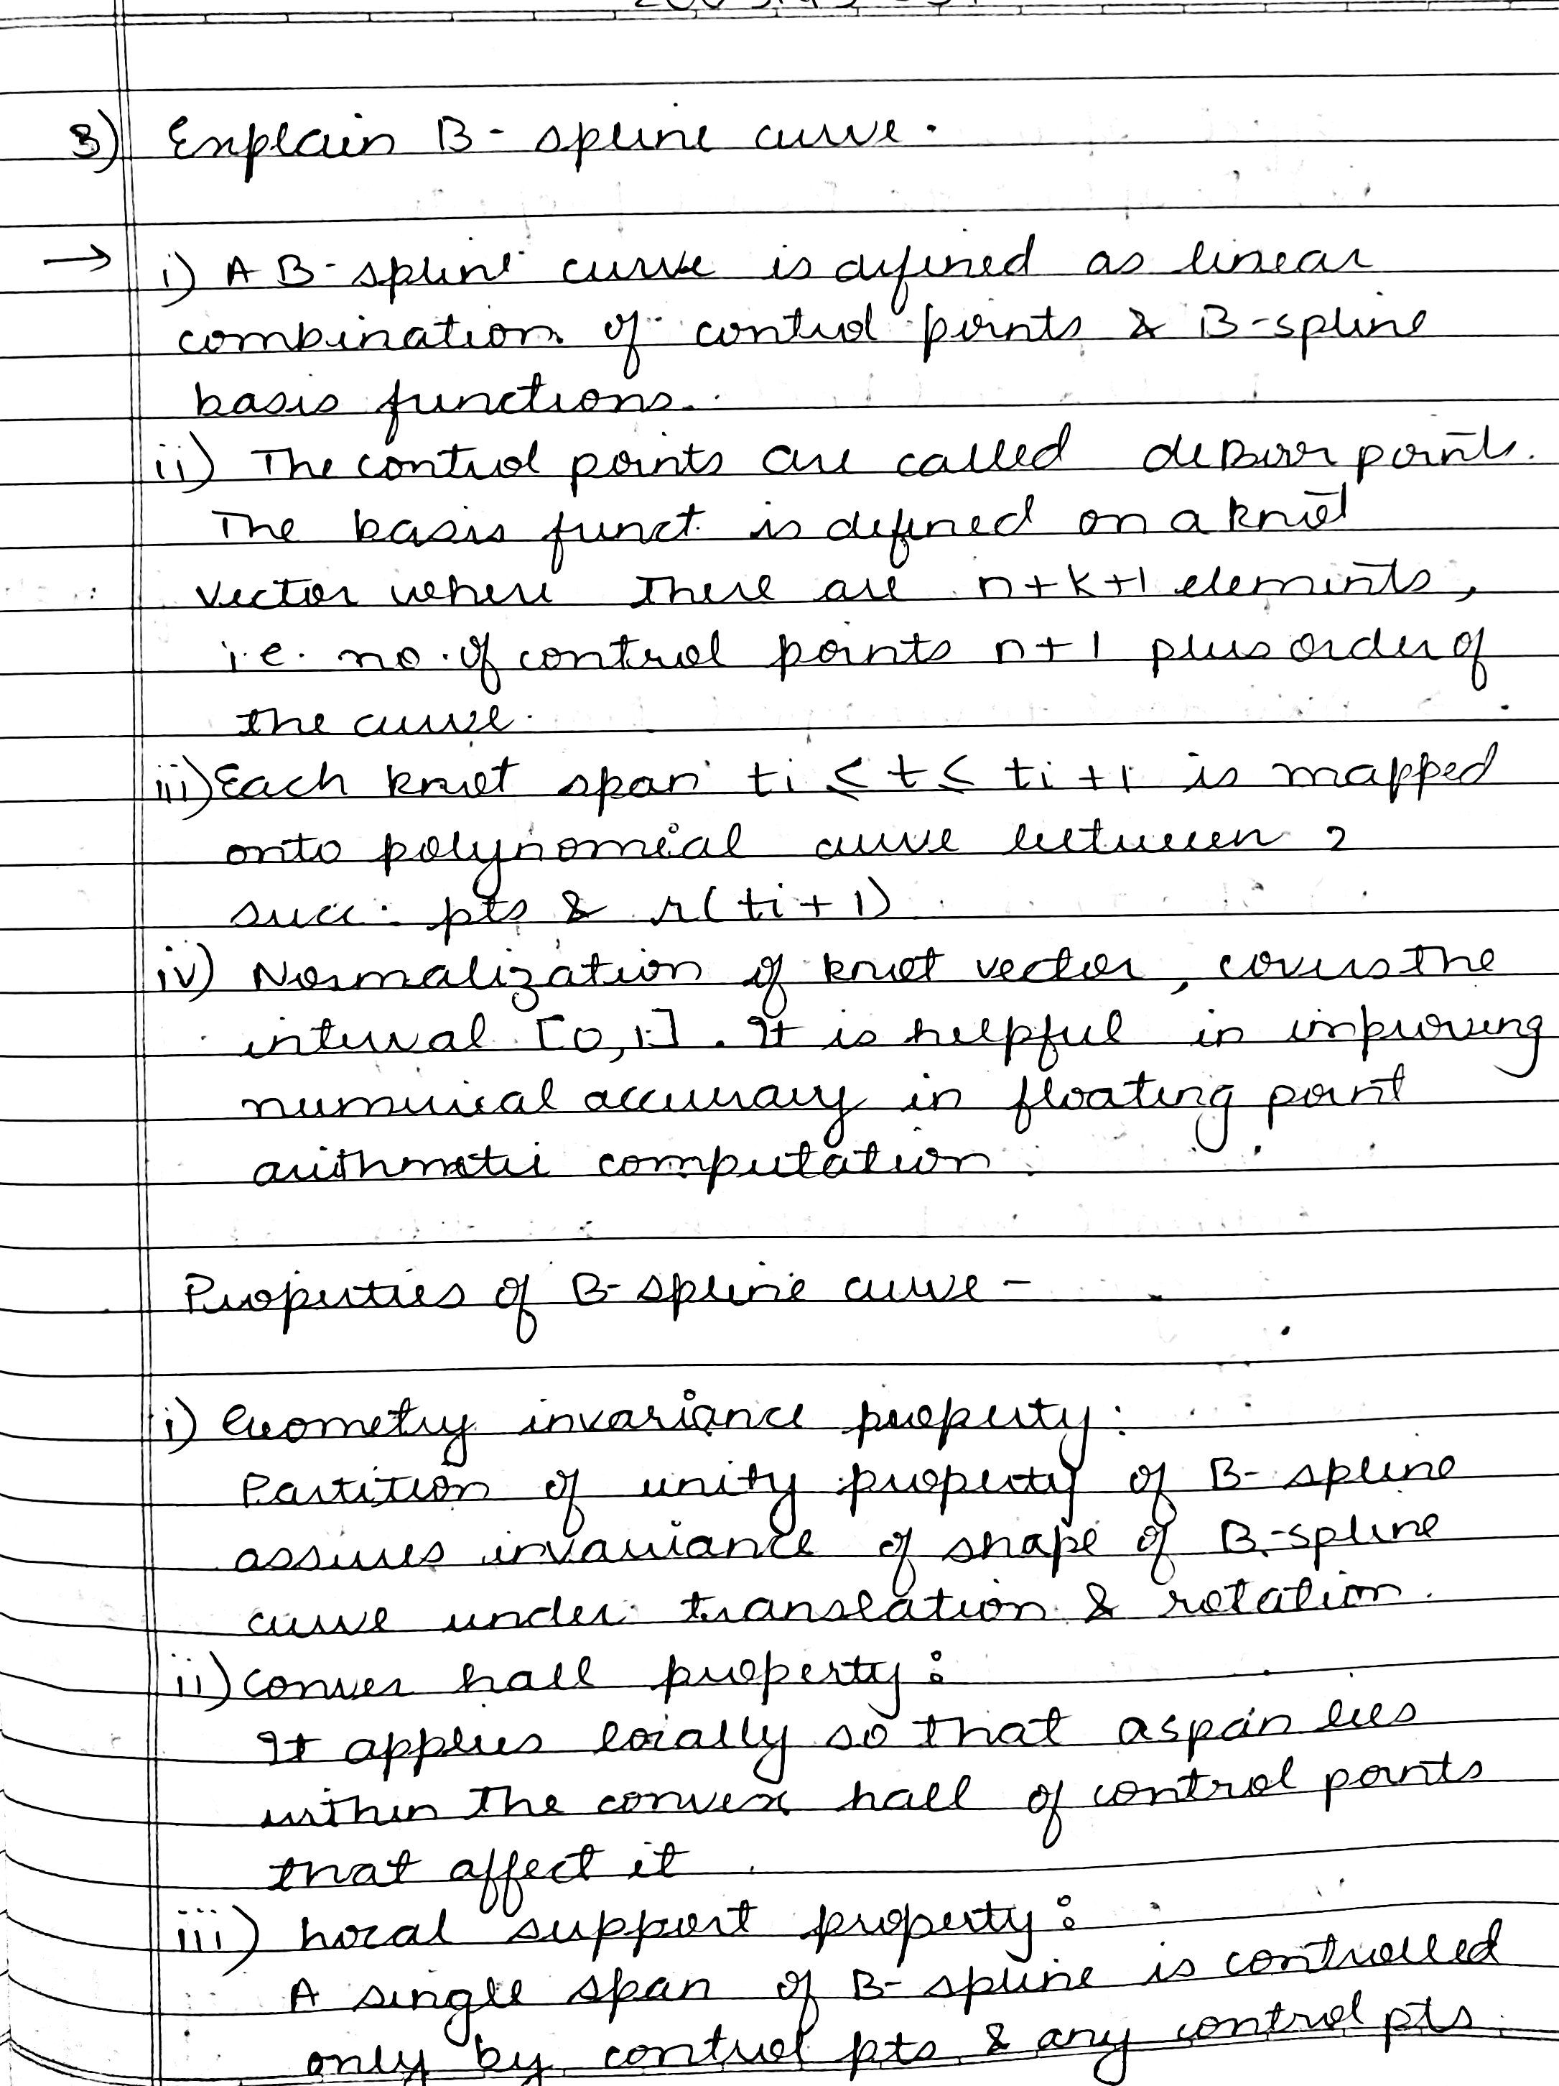

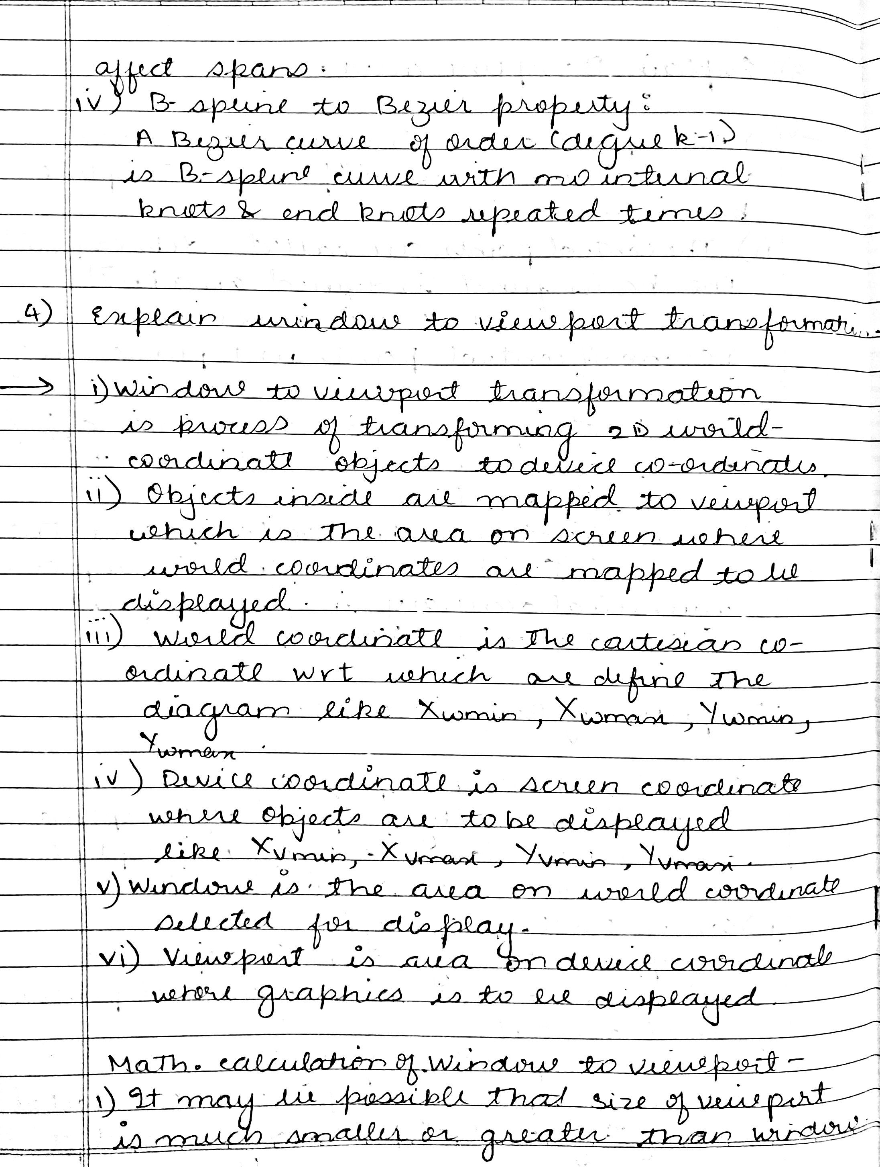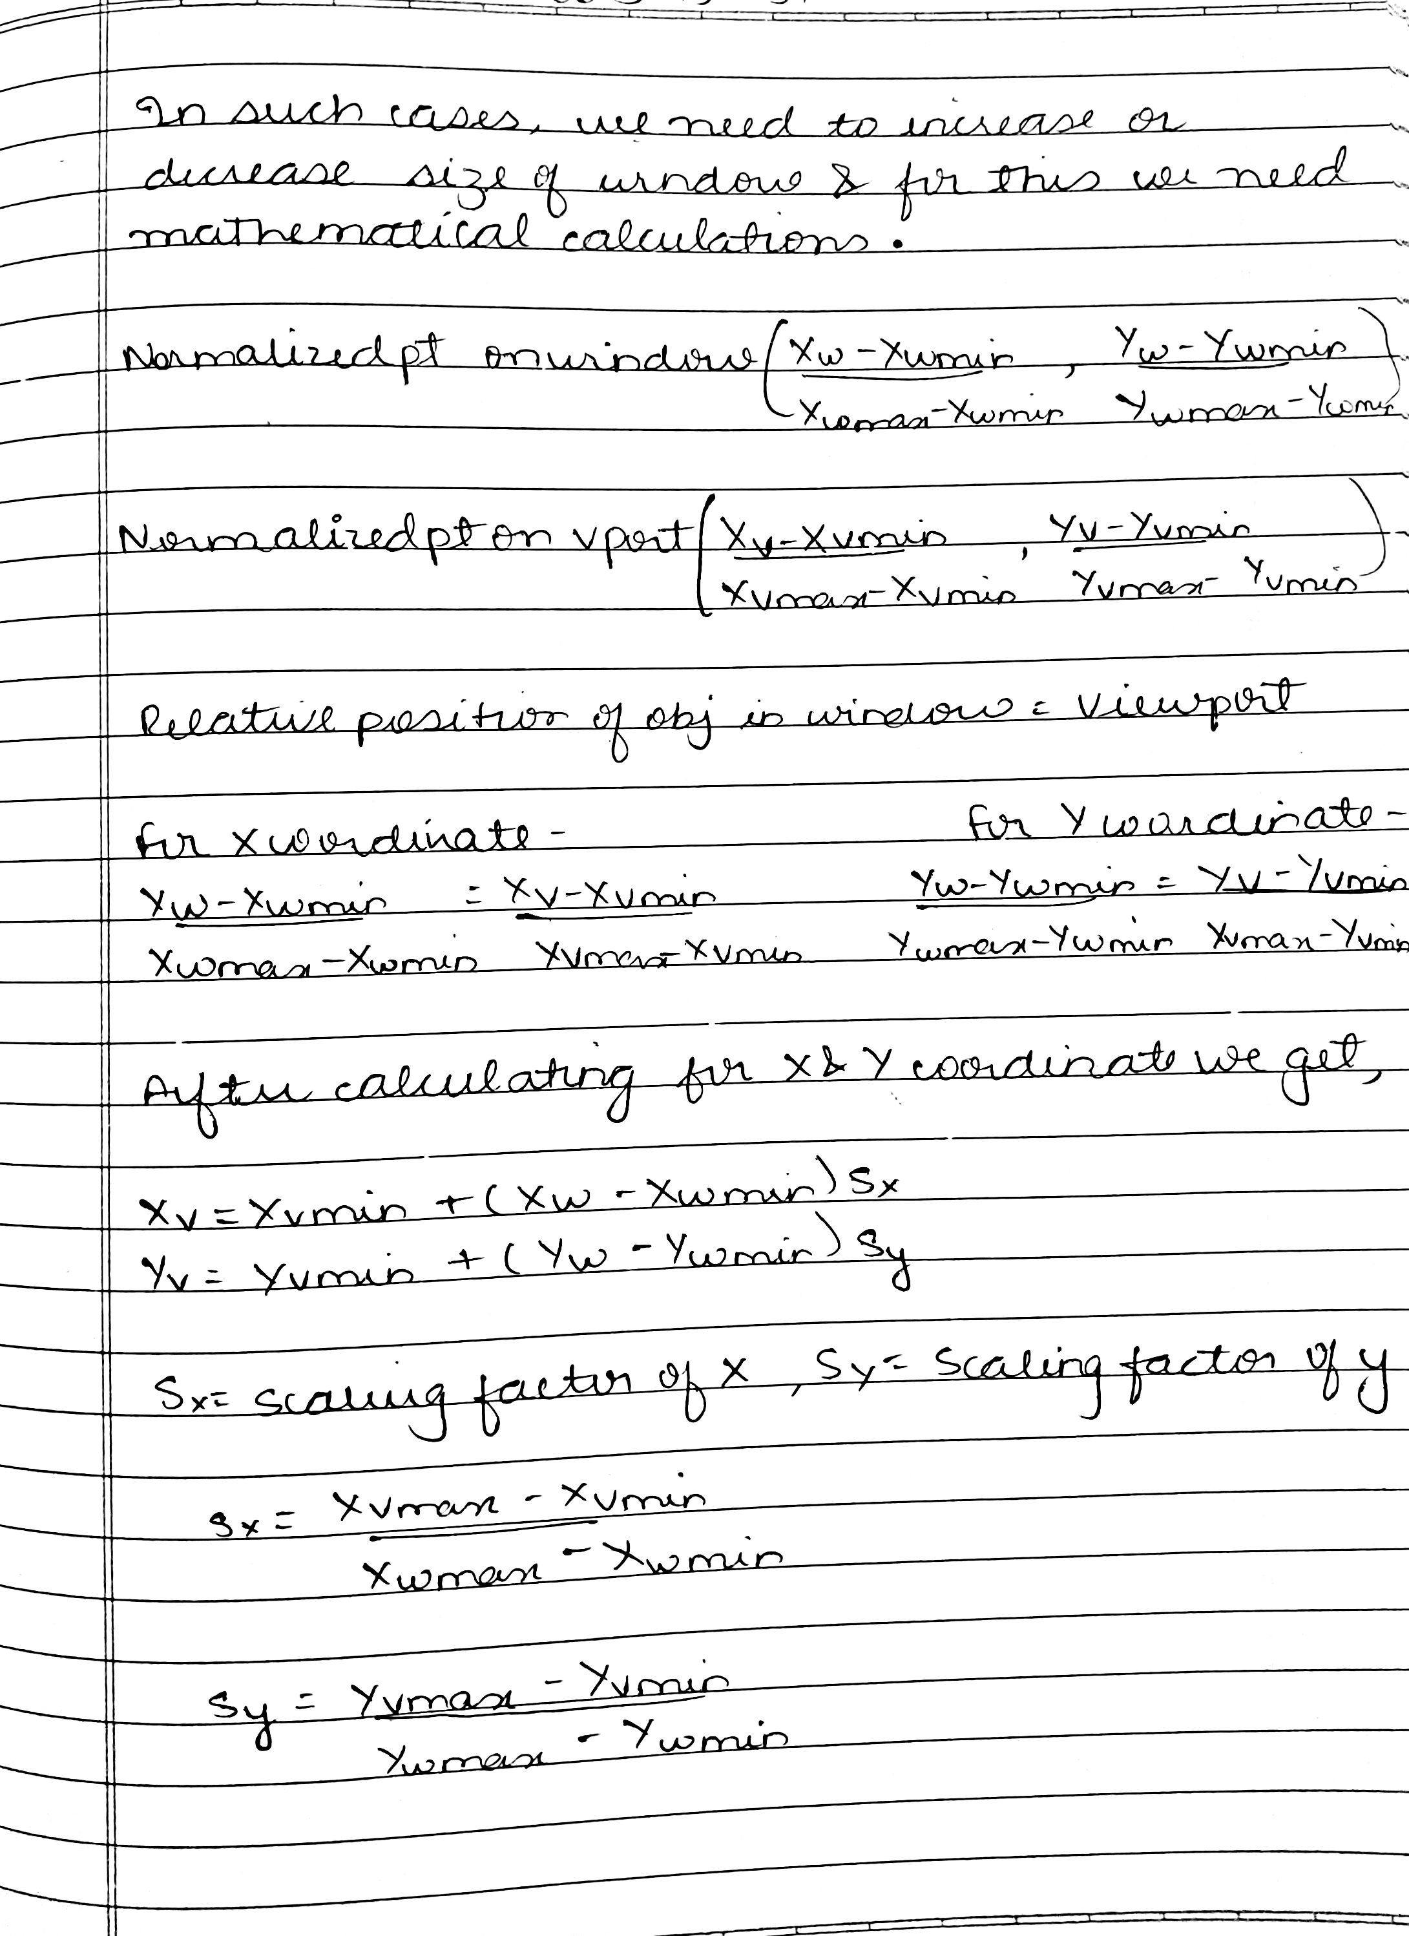

PACMAN GAME

**Idris Ratlamwala - 2003145**

**Lavin Rupani - 2003147**

**Priyansh Salian - 2003148**

**Description :**

The goal of the game is to collect all the points in the maze and avoid the ghosts. The Pacman is animated in two ways: his position in the maze and his body. We animate his body with four images, depending on the direction. The animation is used to create the illusion of Pacman opening and closing his mouth. The maze consists of 15x15 squares. The structure of the maze is based on a simple array of integers. Pacman has three lives. We also count the score.

The Pacman is controlled with the cursor keys. The Esc key finishes the game, the Pause key pauses it.

An array stores the level data which provide information out of which we create the corners and the points. Number 1 is a left corner. Numbers 2, 4 and 8 represent top, right, and bottom corners respectively. Number 16 is a point. These numbers can be added, for example number 19 in the upper left corner means that the square will have top and left borders and a point (16 + 2 + 1).

There are four possible directions for a Pacman. There are four images for all directions. The images are used to animate Pacman opening and closing his mouth.

The drawMaze() method draws the maze out of the numbers in the screenData array. Number 1 is a left border, 2 is a top border, 4 is a right border, 8 is a bottom border and 16 is a point. We simply go through all 225 squares in the maze. For example we have 9 in the screenData array. We have the first bit (1) and the fourth bit (8) set. So we draw a bottom and a left border on this particular square.

**Program :**

Main class (Pacman.java) :

package pacman;

    import javax.swing.JFrame;

    public class Pacman extends JFrame{

        private static final long serialVersionUID = 1L;

        public Pacman() {

            add(new Model());

        }

        public static void main(String[] args) {

            Pacman pac = new Pacman();

            pac.setVisible(true);

            pac.setTitle("Pacman");

            pac.setSize(380,420);

            pac.setDefaultCloseOperation(EXIT_ON_CLOSE);

            pac.setLocationRelativeTo(null);

        }

    }

Model.java class :

package pacman;

    import java.awt.*;

    import java.awt.event.ActionEvent;

    import java.awt.event.ActionListener;

    import java.awt.event.KeyAdapter;

    import java.awt.event.KeyEvent;

    import javax.swing.ImageIcon;

    import javax.swing.JPanel;

    import javax.swing.Timer;

    public class Model extends JPanel implements ActionListener {

        private Dimension d;

        private final Font smallFont = new Font("Arial", Font.BOLD, 14);

        private boolean inGame = false;

        private boolean dying = false;

        private final int BLOCK_SIZE = 24;

        private final int N_BLOCKS = 15;

        private final int SCREEN_SIZE = N_BLOCKS * BLOCK_SIZE;

        private final int MAX_GHOSTS = 12;

        private final int PACMAN_SPEED = 6;

        private int N_GHOSTS = 6;

        private int lives, score;

        private int[] dx, dy;

        private int[] ghost_x, ghost_y, ghost_dx, ghost_dy, ghostSpeed;

        private Image heart, ghost;

        private Image up, down, left, right;

        private int pacman_x, pacman_y, pacmand_x, pacmand_y;

        private int req_dx, req_dy;

        private final short levelData[] = {

            19, 18, 18, 18, 18, 18, 18, 18, 18, 18, 18, 18, 18, 18, 22,

            17, 16, 16, 16, 16, 24, 16, 16, 16, 16, 16, 16, 16, 16, 20,

            25, 24, 24, 24, 28, 0, 17, 16, 16, 16, 16, 16, 16, 16, 20,

            0,  0,  0,  0,  0,  0, 17, 16, 16, 16, 16, 16, 16, 16, 20,

            19, 18, 18, 18, 18, 18, 16, 16, 16, 16, 24, 24, 24, 24, 20,

            17, 16, 16, 16, 16, 16, 16, 16, 16, 20, 0,  0,  0,   0, 21,

            17, 16, 16, 16, 16, 16, 16, 16, 16, 20, 0,  0,  0,   0, 21,

            17, 16, 16, 16, 24, 16, 16, 16, 16, 20, 0,  0,  0,   0, 21,

            17, 16, 16, 20, 0, 17, 16, 16, 16, 16, 18, 18, 18, 18, 20,

            17, 24, 24, 28, 0, 25, 24, 24, 16, 16, 16, 16, 16, 16, 20,

            21, 0,  0,  0,  0,  0,  0,   0, 17, 16, 16, 16, 16, 16, 20,

            17, 18, 18, 22, 0, 19, 18, 18, 16, 16, 16, 16, 16, 16, 20,

            17, 16, 16, 20, 0, 17, 16, 16, 16, 16, 16, 16, 16, 16, 20,

            17, 16, 16, 20, 0, 17, 16, 16, 16, 16, 16, 16, 16, 16, 20,

            25, 24, 24, 24, 26, 24, 24, 24, 24, 24, 24, 24, 24, 24, 28

        };

        private final int validSpeeds[] = {1, 2, 3, 4, 6, 8};

        private final int maxSpeed = 6;

        private int currentSpeed = 3;

        private short[] screenData;

        private Timer timer;

        public Model() {

            loadImages();

            initVariables();

            addKeyListener(new TAdapter());

            setFocusable(true);

            initGame();

        }

        private void loadImages() {

            //down = new ImageIcon("/src/images/down.gif").getImage();

            down = new ImageIcon("C:\\Users\\IsmailRatlamwala\\Downloads\\Pacman-master\\images\\down.gif").getImage();

            up = new ImageIcon("C:\\Users\\IsmailRatlamwala\\Downloads\\Pacman-master\\images\\up.gif").getImage();

            left = new ImageIcon("C:\\Users\\IsmailRatlamwala\\Downloads\\Pacman-master\\images\\left.gif").getImage();

            right = new ImageIcon("C:\\Users\\IsmailRatlamwala\\Downloads\\Pacman-master\\images\\right.gif").getImage();

            ghost = new ImageIcon("C:\\Users\\IsmailRatlamwala\\Downloads\\Pacman-master\\images\\ghost.gif").getImage();

            heart = new ImageIcon("C:\\Users\\IsmailRatlamwala\\Downloads\\Pacman-master\\images\\heart.png").getImage();

        }

        private void initVariables() {

            screenData = new short[N_BLOCKS * N_BLOCKS];

            d = new Dimension(400, 400);

            ghost_x = new int[MAX_GHOSTS];

            ghost_dx = new int[MAX_GHOSTS];

            ghost_y = new int[MAX_GHOSTS];

            ghost_dy = new int[MAX_GHOSTS];

            ghostSpeed = new int[MAX_GHOSTS];

            dx = new int[4];

            dy = new int[4];

            timer = new Timer(40, this);

            timer.start();

        }

        private void playGame(Graphics2D g2d) {

            if (dying) {

                death();

            } else {

                movePacman();

                drawPacman(g2d);

                moveGhosts(g2d);

                checkMaze();

            }

        }

        private void showIntroScreen(Graphics2D g2d) {

            String start = "Press SPACE to start";

            g2d.setColor(Color.yellow);

            g2d.drawString(start, (SCREEN_SIZE)/4, 150);

        }

        private void drawScore(Graphics2D g) {

            g.setFont(smallFont);

            g.setColor(new Color(5, 181, 79));

            String s = "Score: " + score;

            g.drawString(s, SCREEN_SIZE / 2 + 96, SCREEN_SIZE + 16);

            for (int i = 0; i < lives; i++) {

                g.drawImage(heart, i * 28 + 8, SCREEN_SIZE + 1, this);

            }

        }

        private void checkMaze() {

            int i = 0;

            boolean finished = true;

            while (i < N_BLOCKS * N_BLOCKS && finished) {

                if ((screenData[i]) != 0) {

                    finished = false;

                }

                i++;

            }

            if (finished) {

                score += 50;

                if (N_GHOSTS < MAX_GHOSTS) {

                    N_GHOSTS++;

                }

                if (currentSpeed < maxSpeed) {

                    currentSpeed++;

                }

                initLevel();

            }

        }

        private void death() {

            lives--;

            if (lives == 0) {

                inGame = false;

            }

            continueLevel();

        }

        private void moveGhosts(Graphics2D g2d) {

            int pos;

            int count;

            for (int i = 0; i < N_GHOSTS; i++) {

                if (ghost_x[i] % BLOCK_SIZE == 0 && ghost_y[i] % BLOCK_SIZE == 0) {

                    pos = ghost_x[i] / BLOCK_SIZE + N_BLOCKS * (int) (ghost_y[i] / BLOCK_SIZE);

                    count = 0;

                    if ((screenData[pos] & 1) == 0 && ghost_dx[i] != 1) {

                        dx[count] = -1;

                        dy[count] = 0;

                        count++;

                    }

                    if ((screenData[pos] & 2) == 0 && ghost_dy[i] != 1) {

                        dx[count] = 0;

                        dy[count] = -1;

                        count++;

                    }

                    if ((screenData[pos] & 4) == 0 && ghost_dx[i] != -1) {

                        dx[count] = 1;

                        dy[count] = 0;

                        count++;

                    }

                    if ((screenData[pos] & 8) == 0 && ghost_dy[i] != -1) {

                        dx[count] = 0;

                        dy[count] = 1;

                        count++;

                    }

                    if (count == 0) {

                        if ((screenData[pos] & 15) == 15) {

                            ghost_dx[i] = 0;

                            ghost_dy[i] = 0;

                        } else {

                            ghost_dx[i] = -ghost_dx[i];

                            ghost_dy[i] = -ghost_dy[i];

                        }

                    } else {

                        count = (int) (Math.random() * count);

                        if (count > 3) {

                            count = 3;

                        }

                        ghost_dx[i] = dx[count];

                        ghost_dy[i] = dy[count];

                    }

                }

                ghost_x[i] = ghost_x[i] + (ghost_dx[i] * ghostSpeed[i]);

                ghost_y[i] = ghost_y[i] + (ghost_dy[i] * ghostSpeed[i]);

                drawGhost(g2d, ghost_x[i] + 1, ghost_y[i] + 1);

                if (pacman_x > (ghost_x[i] - 12) && pacman_x < (ghost_x[i] + 12)

                        && pacman_y > (ghost_y[i] - 12) && pacman_y < (ghost_y[i] + 12)

                        && inGame) {

                    dying = true;

                }

            }

        }

        private void drawGhost(Graphics2D g2d, int x, int y) {

            g2d.drawImage(ghost, x, y, this);

            }

        private void movePacman() {

            int pos;

            short ch;

            if (pacman_x % BLOCK_SIZE == 0 && pacman_y % BLOCK_SIZE == 0) {

                pos = pacman_x / BLOCK_SIZE + N_BLOCKS * (int) (pacman_y / BLOCK_SIZE);

                ch = screenData[pos];

                if ((ch & 16) != 0) {

                    screenData[pos] = (short) (ch & 15);

                    score++;

                }

                if (req_dx != 0 || req_dy != 0) {

                    if (!((req_dx == -1 && req_dy == 0 && (ch & 1) != 0)

                            || (req_dx == 1 && req_dy == 0 && (ch & 4) != 0)

                            || (req_dx == 0 && req_dy == -1 && (ch & 2) != 0)

                            || (req_dx == 0 && req_dy == 1 && (ch & 8) != 0))) {

                        pacmand_x = req_dx;

                        pacmand_y = req_dy;

                    }

                }

                // Check for standstill

                if ((pacmand_x == -1 && pacmand_y == 0 && (ch & 1) != 0)

                        || (pacmand_x == 1 && pacmand_y == 0 && (ch & 4) != 0)

                        || (pacmand_x == 0 && pacmand_y == -1 && (ch & 2) != 0)

                        || (pacmand_x == 0 && pacmand_y == 1 && (ch & 8) != 0)) {

                    pacmand_x = 0;

                    pacmand_y = 0;

                }

            }

            pacman_x = pacman_x + PACMAN_SPEED * pacmand_x;

            pacman_y = pacman_y + PACMAN_SPEED * pacmand_y;

        }

        private void drawPacman(Graphics2D g2d) {

            if (req_dx == -1) {

                g2d.drawImage(left, pacman_x + 1, pacman_y + 1, this);

            } else if (req_dx == 1) {

                g2d.drawImage(right, pacman_x + 1, pacman_y + 1, this);

            } else if (req_dy == -1) {

                g2d.drawImage(up, pacman_x + 1, pacman_y + 1, this);

            } else {

                g2d.drawImage(down, pacman_x + 1, pacman_y + 1, this);

            }

        }

        private void drawMaze(Graphics2D g2d) {

            short i = 0;

            int x, y;

            for (y = 0; y < SCREEN_SIZE; y += BLOCK_SIZE) {

                for (x = 0; x < SCREEN_SIZE; x += BLOCK_SIZE) {

                    g2d.setColor(new Color(0,72,251));

                    g2d.setStroke(new BasicStroke(5));

                    if ((levelData[i] == 0)) {

                        g2d.fillRect(x, y, BLOCK_SIZE, BLOCK_SIZE);

                    }

                    if ((screenData[i] & 1) != 0) {

                        g2d.drawLine(x, y, x, y + BLOCK_SIZE - 1);

                    }

                    if ((screenData[i] & 2) != 0) {

                        g2d.drawLine(x, y, x + BLOCK_SIZE - 1, y);

                    }

                    if ((screenData[i] & 4) != 0) {

                        g2d.drawLine(x + BLOCK_SIZE - 1, y, x + BLOCK_SIZE - 1,

                                y + BLOCK_SIZE - 1);

                    }

                    if ((screenData[i] & 8) != 0) {

                        g2d.drawLine(x, y + BLOCK_SIZE - 1, x + BLOCK_SIZE - 1,

                                y + BLOCK_SIZE - 1);

                    }

                    if ((screenData[i] & 16) != 0) {

                        g2d.setColor(new Color(255,255,255));

                        g2d.fillOval(x + 10, y + 10, 6, 6);

                }

                    i++;

                }

            }

        }

        private void initGame() {

            lives = 3;

            score = 0;

            initLevel();

            N_GHOSTS = 6;

            currentSpeed = 3;

        }

        private void initLevel() {

            int i;

            for (i = 0; i < N_BLOCKS * N_BLOCKS; i++) {

                screenData[i] = levelData[i];

            }

            continueLevel();

        }

        private void continueLevel() {

            int dx = 1;

            int random;

            for (int i = 0; i < N_GHOSTS; i++) {

                ghost_y[i] = 4 * BLOCK_SIZE; //start position

                ghost_x[i] = 4 * BLOCK_SIZE;

                ghost_dy[i] = 0;

                ghost_dx[i] = dx;

                dx = -dx;

                random = (int) (Math.random() * (currentSpeed + 1));

                if (random > currentSpeed) {

                    random = currentSpeed;

                }

                ghostSpeed[i] = validSpeeds[random];

            }

            pacman_x = 7 * BLOCK_SIZE;  //start position

            pacman_y = 11 * BLOCK_SIZE;

            pacmand_x = 0;  //reset direction move

            pacmand_y = 0;

            req_dx = 0;     // reset direction controls

            req_dy = 0;

            dying = false;

        }

        public void paintComponent(Graphics g) {

            super.paintComponent(g);

            Graphics2D g2d = (Graphics2D) g;

            g2d.setColor(Color.black);

            g2d.fillRect(0, 0, d.width, d.height);

            drawMaze(g2d);

            drawScore(g2d);

            if (inGame) {

                playGame(g2d);

            } else {

                showIntroScreen(g2d);

            }

            Toolkit.getDefaultToolkit().sync();

            g2d.dispose();

        }

        //controls

        class TAdapter extends KeyAdapter {

            @Override

            public void keyPressed(KeyEvent e) {

                int key = e.getKeyCode();

                if (inGame) {

                    if (key == KeyEvent.VK_LEFT) {

                        req_dx = -1;

                        req_dy = 0;

                    } else if (key == KeyEvent.VK_RIGHT) {

                        req_dx = 1;

                        req_dy = 0;

                    } else if (key == KeyEvent.VK_UP) {

                        req_dx = 0;

                        req_dy = -1;

                    } else if (key == KeyEvent.VK_DOWN) {

                        req_dx = 0;

                        req_dy = 1;

                    } else if (key == KeyEvent.VK_ESCAPE && timer.isRunning()) {

                        inGame = false;

                    }

                } else {

                    if (key == KeyEvent.VK_SPACE) {

                        inGame = true;

                        initGame();

                    }

                }

            }

    }

        @Override

        public void actionPerformed(ActionEvent e) {

            repaint();

        }

        }

**Images :**

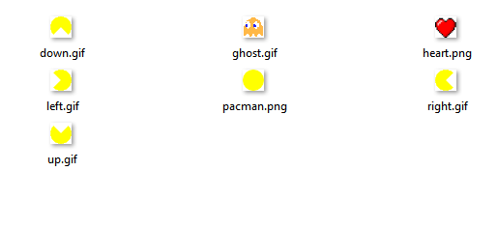

**Output :**

